 **MINISTRY OF EDUCATION AND TRAINING**

**FPT UNIVERSITY**

Capstone Project Document

**Timetable Management Support Tools**

|  |  |
| --- | --- |
| **Group 6** | |
| **Group member** | Lu Quoc Cuong - SE60940  Pham Tran Tuan Vu - SE61063  Ho Thien Nguyen - SE60850  Ha Trong Trung – SE60597 |
| **Supervisor** | Mr. Kieu Trong Khanh |
| **Ext. Supervisor** | N/A |
| **Capstone Project code** | TMST |

-Ho Chi Minh City, 05/01/2015-

# Table of Contents

Table of Contents 3

List of Tables 4

List of Figures 5

Definitions, Acronyms, and Abbreviations 7

D. Software Design Description 8

1. Design Overview 8

2. System Architectural Design 8

3. Component Diagram 9

4. Detailed Description 10

4.1 Class Diagram 10

4.2 Class Diagram Explanation 12

4.3 Interaction Diagram 17

5. User Interface Design 30

5.1 Guest Interface Design 30

5.2 Staff Interface Design 30

6. Database Design 61

6.1 Logical Diagram 61

6.2 Data Dictionary 62

7. Algorithms 66

7.1 Suggest Temporary Timetable 66

7.2 Suggest Complete Timetable 66

7.3 Choose Slot 67

7.4 Suggest Room 69

7.5 Suggest Guide Project Schedule 69

# List of Tables

Table 1: Component Dictionary 10

Table 2: Class Dictionary 12

Table 3: Entity Data Dictionary 63

Table 4: Detail Data Dictionary 66

# List of Figures

Figure 1: TMST System Architectural 8

Figure 2: Component Diagram 9

Figure 3: Class Diagram 11

Figure 4: Sequence Diagram <Staff>Import Plan Semester 18

Figure 5: Sequence Diagram <Staff>Import Class in Semester 18

Figure 6: Sequence Diagram <Staff>Create Temporary Timetable 19

Figure 7: Sequence Diagram <Staff>View Temporary Timetable 19

Figure 8: Sequence Diagram <Staff>Edit Temporary Timetable 20

Figure 9: Sequence Diagram<Staff>Export Temporary Timetable 20

Figure 10: Sequence Diagram <Staff>Import Instructor List 21

Figure 11: Sequence Diagram <Staff>Check Conflict (Temporary Timetable) 21

Figure 12: Sequence Diagram <Staff>Create Complete Timetable 22

Figure 13: Sequence Diagram <Staff>View Complete Timetable 23

Figure 14: Sequence Diagram <Staff>Check Conflict (Complete Timetable) 23

Figure 15: Sequence Diagram <Staff>Export Complete Timetable 24

Figure 16: Sequence Diagram <Staff>Edit Complete Timetable 24

Figure 17: Sequence Diagram <Staff>Send Mail (Complete Timetable) 25

Figure 18: Sequence Diagram <Staff>Import Project Group 26

Figure 19: Sequence Diagram <Staff>Create Project Schedule 27

Figure 20: Sequence Diagram <Staff>Export Project Schedule 27

Figure 21: Sequence Diagram <Staff>Send Mail (Project Schedule) 28

Figure 22: Sequence Diagram <Staff>Calculate Timekeeping 28

Figure 23: Sequence Diagram <Staff>Suggest Room 29

Figure 24: Sequence Diagram <Staff>Export Room Usage Schedule 29

Figure 25: Sequence Diagram <Staff>Send Mail (Time Keeping) 30

Figure 26: Login 30

Figure 27: Create New Semester Step 1 31

Figure 28: Create New Semester Step 2 32

Figure 29: Chose Semester 33

Figure 30: Import Plan Semester 33

Figure 31: Import Plan Semester 34

Figure 32: Suggest Temporary Timetable 35

Figure 33: Manage Temporary Timetable 36

Figure 34: Add course 37

Figure 35: Edit Temporary Timetable 38

Figure 36: Export Temporary Timetable 40

Figure 37: Suggest Complete Timetable 41

Figure 38: Manage Complete Timetable 42

Figure 39: Add Complete Timetable 43

Figure 40: Change Slot 44

Figure 41: Update Instructor 45

Figure 42: Move Date 47

Figure 43: Delete Complete Timetable 48

Figure 44: Adjust 12 Weeks 49

Figure 45: Export Complete Timetable 50

Figure 46: Send Mail (Complete Timetable) 51

Figure 47: Import Project Group 52

Figure 48: Manage Project Group 53

Figure 49: Suggest Project Schedule 54

Figure 50: Manage Project Schedule 55

Figure 51: Send mail (Project Schedule) 56

Figure 52: Export Project Schedule 57

Figure 53: Calculate Timekeeping 58

Figure 54: Send Timekeeping 59

Figure 55: View Room Usage 60

Figure 56: Export Room Usage 60

Figure 57: Logical Diagram 62

Figure 58: Suggest Temporary Timetable 66

Figure 59: Suggest Complete Timetable 67

Figure 60: Choose Slot 68

Figure 61: Suggest Room 69

Figure 62: Suggest Guide Project Schedule 70

# Definitions, Acronyms, and Abbreviations

|  |  |
| --- | --- |
| **Name** | **Definition** |
| TMST | Timetable Management Support Tools |
| API | Application Programming Interface |

# Software Design Description

## Design Overview

* This document describes the technical and user interface design of Timetable Management Support Tools. It includes the architectural design, the detailed design of common functions and business functions.
* The architectural design describes the overall architecture of the system and the architecture of each main component and subsystem.
* The detailed design describes static and dynamic structure for each component and functions. It includes class diagrams, class explanations and sequence diagrams for each use cases.
* The database design describes the relationships between entities and details of each entity.
* Document overview:
* **Section 2:** The overall description of the system architectural design.
* **Section 3:** Component diagrams that describe the connection and integration of the system.
* **Section 4:** Detail design description, which includes class diagram, class explanation, and sequence diagram to describe the application functions.
* **Section 5:** The user interface of application.
* **Section 6:** Database design with entity relationship diagram.
* **Section 7:** The algorithms used for timetable, schedule suggestion.

## System Architectural Design

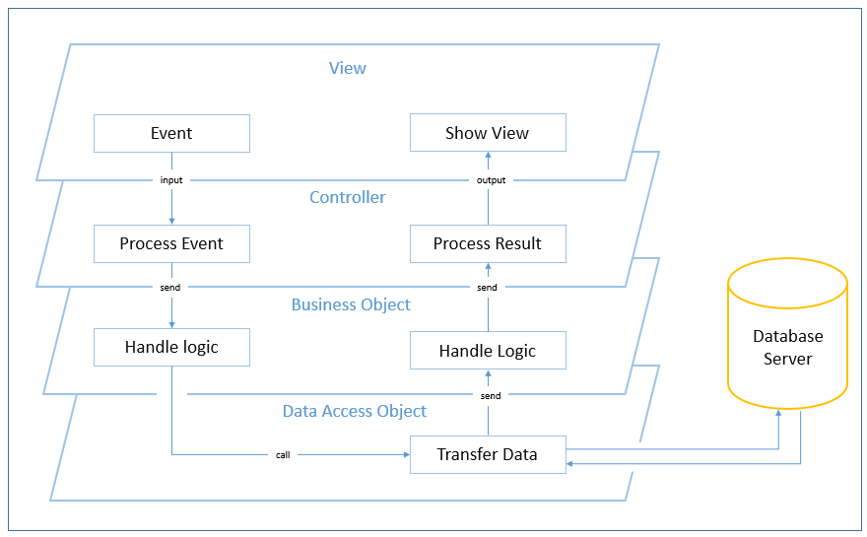

Figure : TMST System Architectural

* The System Architectural model of system is Multi Layered Architecture (MLA) model for some reason:

+ TMST is a desktop application which contain many features, so using MLA model could reduce complexity of code, and also reduce code per layer.

+ Requirement is changed and updated frequently, so using MLA model could provide the easy way to test, maintain code and add new functionality or reuse code.

## Component Diagram

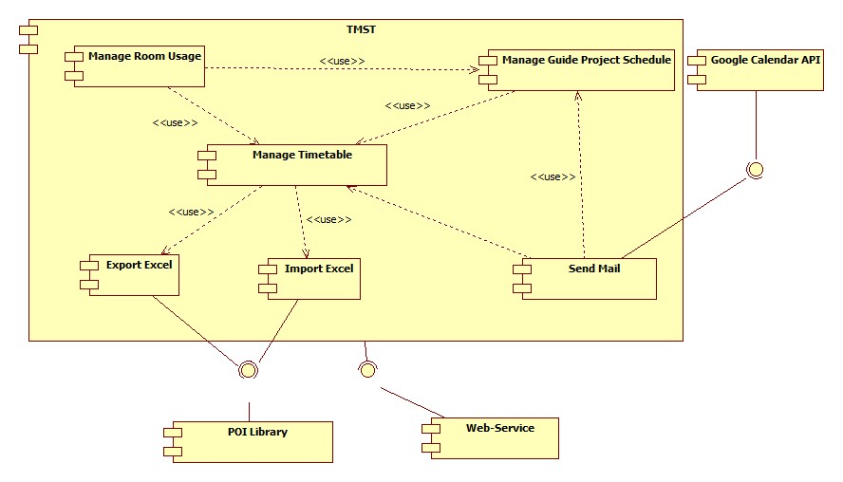

Figure : Component Diagram

|  |  |
| --- | --- |
| Component dictionary | |
| Component Name | Description |
| Manage Timetable | Component contains all modules about Suggest, Create, Edit, Check Conflict Temporary Timetable and Completed Timetable. |
| Manage Room Usage | Component contains all modules about Suggest, View, and Edit Room Usage. |
| Manage Guide Project Schedule | Component contains all modules about Suggest, View, and Edit Guide Project Schedule. |
| Export Excel | Component contains module that is used to export Timetable, Manage Guide Project Schedule, and Room Usage to Excel file. |
| Import Excel | Component contains module that is used to import Plan Semester, Class List, Instructor List, and Guide Project List into System. |
| Send Mail | Component contains module that is used to send Timekeeping, Timetable, and Project Schedule to Instructor. |
| POI library | Component contains library that is used for system can import or export excel file. Download at:  <http://poi.apache.org/download.html> |
| Web Service | Component contains module that is used for get access key to system can synchronize Timetable and Guide Project Schedule to Google Calendar. |
| Google Calendar API | Component contains Google Calendar API to help system can synchronize and send mail to Google Calendar. |

Table : Component Dictionary

## Detailed Description

### Class Diagram

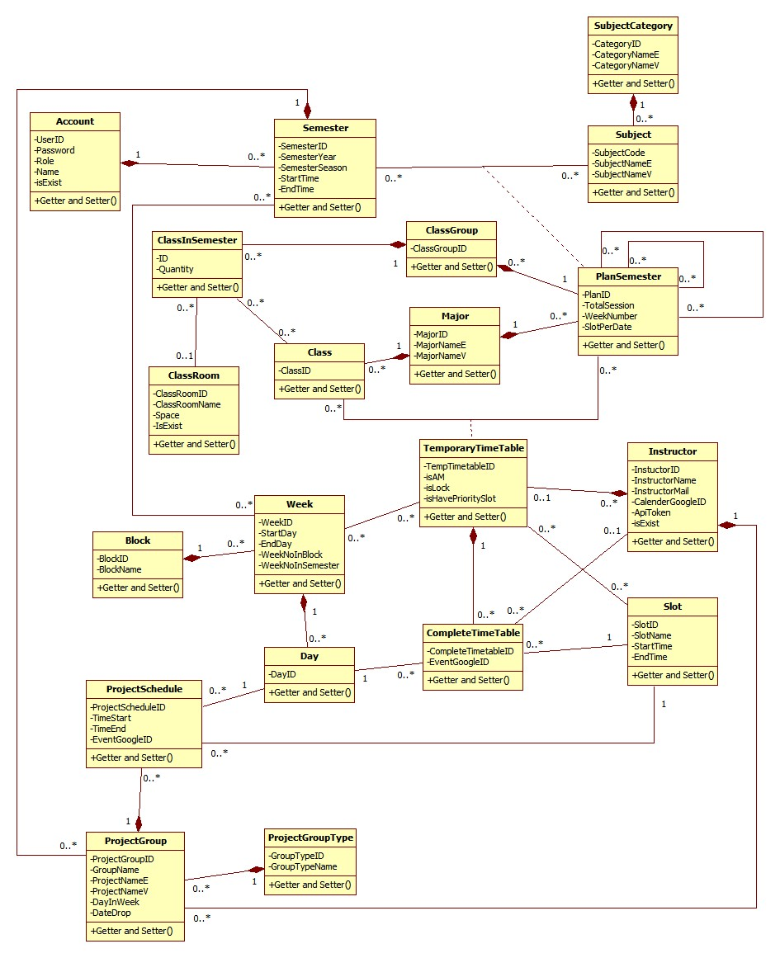

Figure : Class Diagram

|  |  |
| --- | --- |
| **Class dictionary** | |
| **Class Name** | **Description** |
| Account | Describe all user of the system. Each user has only one account. |
| Semester | Describe the semesters of FPT University, each semester at FPT University is about 4 months. |
| ClassRoom | Describe the rooms of FPT University which can be used for teaching. |
| Class | Describe the classes in FPT University. Each class is a set of students who have same courses. |
| ClassInSemester | Describe the specific class in a specific semester. |
| ClassGroup | Describe the sets of class in FPT University have the same plan in a semester. |
| Major | Describe the sets of class in FPT University have the same major. |
| Slot | Describe the slot in FPT University. Each slot is 90 minutes. |
| Day | Describe the official day in FPT University’s curriculum. Each day has 8 slots. |
| Week | Describe the week in FPT University’s curriculum. |
| Block | Describe the sets of weeks defined by FPT University. |
| Subject | Describe all available subject in FPT University. |
| SubjectCategory | Describe the sets of Subject. |
| PlanSemester | Describe the specific subjects which are available for each class group in a specific semester. Each semester has many plan semesters. |
| Instructor | Describe all instructors in FPT University. |
| CompletedTimetable | Describe the timetable in FPT University. Each timetable is about a set of answers for these question: which class has which subjects, teaching by who (instructor), at which specific period? |
| TemporaryTimetable | Describe the timetable in a brief description way. |
| ProjectGroup | Describe the set of students who is doing Capstone Project and Graduation Thesis. |
| ProjectGroupType | Describe the type of project group. |
| ProjectSchedule | Describe the time for meeting of project groups with their Instructor. |

Table : Class Dictionary

### Class Diagram Explanation

#### Account

Attribute

|  |  |  |  |
| --- | --- | --- | --- |
| **Attribute** | **Type** | **Visibility** | **Description** |
| UserID | String | Private | Unique identifier of an Account |
| Password | String | Private | Password of account user |
| Role | Integer | Private | Role name |
| Name | String | Private | Name of account user |
| isExist | Boolean | Private | Identifier of active account or not |

Method

|  |  |  |  |
| --- | --- | --- | --- |
| **Method** | **Return type** | **Visibility** | **Description** |
| Getter | Attribute type | Public | Get attribute value |
| Setter | Void | Public | Set value of attribute |

#### Semester

Attribute

|  |  |  |  |
| --- | --- | --- | --- |
| **Attribute** | **Type** | **Visibility** | **Description** |
| SemesterID | Interger | Private | ID of semester |
| SemesterYear | Interger | Private | Year of semester |
| SemesterSeason | String | Private | Season of semester |
| StartTime | Date | Private | Start time of a semester |
| EndTime | Date | Private | End time of a semester |

Method

|  |  |  |  |
| --- | --- | --- | --- |
| **Method** | **Return type** | **Visibility** | **Description** |
| Getter | Attribute type | Public | Get attribute value |
| Setter | Void | Public | Set value of attribute |

#### SubjectCategory

Attribute

|  |  |  |  |
| --- | --- | --- | --- |
| **Attribute** | **Type** | **Visibility** | **Description** |
| CategoryID | String | Private | ID of category |
| CategoryNameE | String | Private | Category name in English |
| CategoryNameV | String | Private | Category name in Vietnamese |

Method

|  |  |  |  |
| --- | --- | --- | --- |
| **Method** | **Return type** | **Visibility** | **Description** |
| Getter | Attribute type | Public | Get attribute value |
| Setter | Void | Public | Set value of attribute |

#### Subject

Attribute

|  |  |  |  |
| --- | --- | --- | --- |
| **Attribute** | **Type** | **Visibility** | **Description** |
| SubjectCode | String | Private | ID of subject |
| SubjectNameE | String | Private | Subject name in English |
| SubjectNameV | String | Private | Subject name in Vietnamese |

Method

|  |  |  |  |
| --- | --- | --- | --- |
| **Method** | **Return type** | **Visibility** | **Description** |
| Getter | Attribute type | Public | Get attribute value |
| Setter | Void | Public | Set value of attribute |

#### PlanSemester

Attribute

|  |  |  |  |
| --- | --- | --- | --- |
| **Attribute** | **Type** | **Visibility** | **Description** |
| PlanID | Integer | Private | ID of a plan semester |
| TotalSession | Integer | Private | Number of session for a plan semester |
| WeekNumber | Integer | Private | Number of week for a plan semester |
| SlotPerDate | Integer | Private | Number of slot for a plan semester |

Method

|  |  |  |  |
| --- | --- | --- | --- |
| **Method** | **Return type** | **Visibility** | **Description** |
| Getter | Attribute type | Public | Get attribute value |
| Setter | Void | Public | Set value of attribute |

#### Major

Attribute

|  |  |  |  |
| --- | --- | --- | --- |
| **Attribute** | **Type** | **Visibility** | **Description** |
| MajorID | String | Private | ID of major |
| MajorNameE | String | Private | Name of major in English |
| MajorNameV | String | Private | Name of major in VietNam |

Method

|  |  |  |  |
| --- | --- | --- | --- |
| **Method** | **Return type** | **Visibility** | **Description** |
| Getter | Attribute type | Public | Get attribute value |
| Setter | Void | Public | Set value of attribute |

#### ClassGroup

Attribute

|  |  |  |  |
| --- | --- | --- | --- |
| **Attribute** | **Type** | **Visibility** | **Description** |
| ClassGroupID | Integer | Private | ID of group class |

Method

|  |  |  |  |
| --- | --- | --- | --- |
| **Method** | **Return type** | **Visibility** | **Description** |
| Getter | Attribute type | Public | Get attribute value |
| Setter | Void | Public | Set value of attribute |

#### Class

Attribute

|  |  |  |  |
| --- | --- | --- | --- |
| **Attribute** | **Type** | **Visibility** | **Description** |
| ClassID | String | Private | ID of class |

Method

|  |  |  |  |
| --- | --- | --- | --- |
| **Method** | **Return type** | **Visibility** | **Description** |
| Getter | Attribute type | Public | Get attribute value |
| Setter | Void | Public | Set value of attribute |

#### ClassInSemester

Attribute

|  |  |  |  |
| --- | --- | --- | --- |
| **Attribute** | **Type** | **Visibility** | **Description** |
| ID | Integer | Private | ID of a class in semester |
| Quantity | Integer | Private | Number of student of class in semester |

Method

|  |  |  |  |
| --- | --- | --- | --- |
| **Method** | **Return type** | **Visibility** | **Description** |
| Getter | Attribute type | Public | Get attribute value |
| Setter | Void | Public | Set value of attribute |

#### ClassRoom

Attribute

|  |  |  |  |
| --- | --- | --- | --- |
| **Attribute** | **Type** | **Visibility** | **Description** |
| ClassRoomID | Integer | Private | ID of classroom |
| ClassRoomName | String | Private | Name of classroom |
| Space | Integer | Private | Room space of classroom |
| IsExist | Boolean | Private | Identifier if room is valid to use |

Method

|  |  |  |  |
| --- | --- | --- | --- |
| **Method** | **Return type** | **Visibility** | **Description** |
| Getter | Attribute type | Public | Get attribute value |
| Setter | Void | Public | Set value of attribute |

#### TemporaryTimeTable

Attribute

|  |  |  |  |
| --- | --- | --- | --- |
| **Attribute** | **Type** | **Visibility** | **Description** |
| TempTimetableID | Integer | Private | ID of temporary timetable |
| isAM | Boolean | Private | Identifier if timetable is AM or PM |
| isLock | Boolean | Private | Identifier if timetable is lock |
| isHavePrioritySlot | Boolean | Private | Identifier if timetable have priority slot |

Method

|  |  |  |  |
| --- | --- | --- | --- |
| **Method** | **Return type** | **Visibility** | **Description** |
| Getter | Attribute type | Public | Get attribute value |
| Setter | Void | Public | Set value of attribute |

#### Slot

Attribute

|  |  |  |  |
| --- | --- | --- | --- |
| **Attribute** | **Type** | **Visibility** | **Description** |
| SlotID | Integer | Private | ID of slot |
| SlotName | String | Private | Name of slot |
| StartTime | Time | Private | Start time of slot in a day |
| EndTime | Time | Private | End time of slot in day |

Method

|  |  |  |  |
| --- | --- | --- | --- |
| **Method** | **Return type** | **Visibility** | **Description** |
| Getter | Attribute type | Public | Get attribute value |
| Setter | Void | Public | Set value of attribute |

#### Instructor

Attribute

|  |  |  |  |
| --- | --- | --- | --- |
| **Attribute** | **Type** | **Visibility** | **Description** |
| InstuctorID | Integer | Private | ID in instructor |
| InstructorName | String | Private | Name of instructor |
| InstructorMail | String | Private | Mail of instructor |
| CalenderGoogleID | String | Private | ID of Google calendar |
| ApiToken | String | Private | Access token to synchronize Google calendar |
| isExist | Boolean | Private | Identifier if instructor is valid to use |

Method

|  |  |  |  |
| --- | --- | --- | --- |
| **Method** | **Return type** | **Visibility** | **Description** |
| Getter | Attribute type | Public | Get attribute value |
| Setter | Void | Public | Set value of attribute |

#### Block

Attribute

|  |  |  |  |
| --- | --- | --- | --- |
| **Attribute** | **Type** | **Visibility** | **Description** |
| BlockID | Integer | Private | ID of block in semester |
| BlockName | String | Private | Name of block in semester |

Method

|  |  |  |  |
| --- | --- | --- | --- |
| **Method** | **Return type** | **Visibility** | **Description** |
| Getter | Attribute type | Public | Get attribute value |
| Setter | Void | Public | Set value of attribute |

#### Week

Attribute

|  |  |  |  |
| --- | --- | --- | --- |
| **Attribute** | **Type** | **Visibility** | **Description** |
| WeekID | Integer | Private | Unique identifier of a week |
| StartDay | Date | Private | The start date of this week |
| EndDay | Date | Private | The end date of this week |
| WeekNoInBlock | Integer | Private | Ordinal numbers of week in a block |
| WeekNoInSemester | Integer | Private | Ordinal numbers of week in the semester |

Method

|  |  |  |  |
| --- | --- | --- | --- |
| **Method** | **Return type** | **Visibility** | **Description** |
| Getter | Attribute type | Public | Get attribute value |
| Setter | Void | Public | Set value of attribute |

#### Day

Attribute

|  |  |  |  |
| --- | --- | --- | --- |
| **Attribute** | **Type** | **Visibility** | **Description** |
| DayID | Date | Private | Unique identifier of a date |

Method

|  |  |  |  |
| --- | --- | --- | --- |
| **Method** | **Return type** | **Visibility** | **Description** |
| Getter | Attribute type | Public | Get attribute value |
| Setter | Void | Public | Set value of attribute |

#### CompleteTimeTable

Attribute

|  |  |  |  |
| --- | --- | --- | --- |
| **Attribute** | **Type** | **Visibility** | **Description** |
| CompleteTimetableID | Integer | Private | ID of complete timetable |
| EventGoogleID | String | Private | ID of Google Event |

Method

|  |  |  |  |
| --- | --- | --- | --- |
| **Method** | **Return type** | **Visibility** | **Description** |
| Getter | Attribute type | Public | Get attribute value |
| Setter | Void | Public | Set value of attribute |

#### ProjectGroupType

Attribute

|  |  |  |  |
| --- | --- | --- | --- |
| **Attribute** | **Type** | **Visibility** | **Description** |
| GroupTypeID | Integer | Private | ID of group type |
| GroupTypeName | String | Private | Name of group type |

Method

|  |  |  |  |
| --- | --- | --- | --- |
| **Method** | **Return type** | **Visibility** | **Description** |
| Getter | Attribute type | Public | Get attribute value |
| Setter | Void | Public | Set value of attribute |

#### ProjectGroup

Attribute

|  |  |  |  |
| --- | --- | --- | --- |
| **Attribute** | **Type** | **Visibility** | **Description** |
| ProjectGroupID | Integer | Private | ID of project group |
| GroupName | String | Private | Topic name of project group |
| ProjectNameE | String | Private | Name project in English |
| ProjectNameV | String | Private | Name project in Vietnamese |
| DayInWeek | Integer | Private | Number of meeting times with instructor in a week |
| DateDrop | Date | Private | Date drop if a group dropped |

Method

|  |  |  |  |
| --- | --- | --- | --- |
| **Method** | **Return type** | **Visibility** | **Description** |
| Getter | Attribute type | Public | Get attribute value |
| Setter | Void | Public | Set value of attribute |

#### ProjectSchedule

Attribute

|  |  |  |  |
| --- | --- | --- | --- |
| **Attribute** | **Type** | **Visibility** | **Description** |
| ProjectScheduleID | Integer | Private | ID of project schedule |
| TimeStart | Time | Private | Time start of project schedule |
| TimeEnd | Time | Private | Time end of project schedule |
| EventGoogleID | String | Private | ID of Google event |

Method

|  |  |  |  |
| --- | --- | --- | --- |
| **Method** | **Return type** | **Visibility** | **Description** |
| Getter | Attribute type | Public | Get attribute value |
| Setter | Void | Public | Set value of attribute |

### Interaction Diagram

#### <Staff>Import Plan Semester

**Summary:** This diagram shows how staff import plan semester into system.

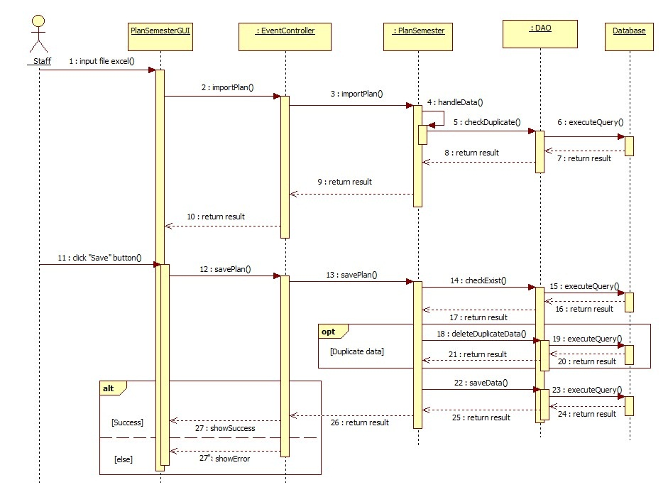

Figure : Sequence Diagram <Staff>Import Plan Semester

#### <Staff>Import Class in Semester

**Summary:** This diagram shows how staff import class into system.

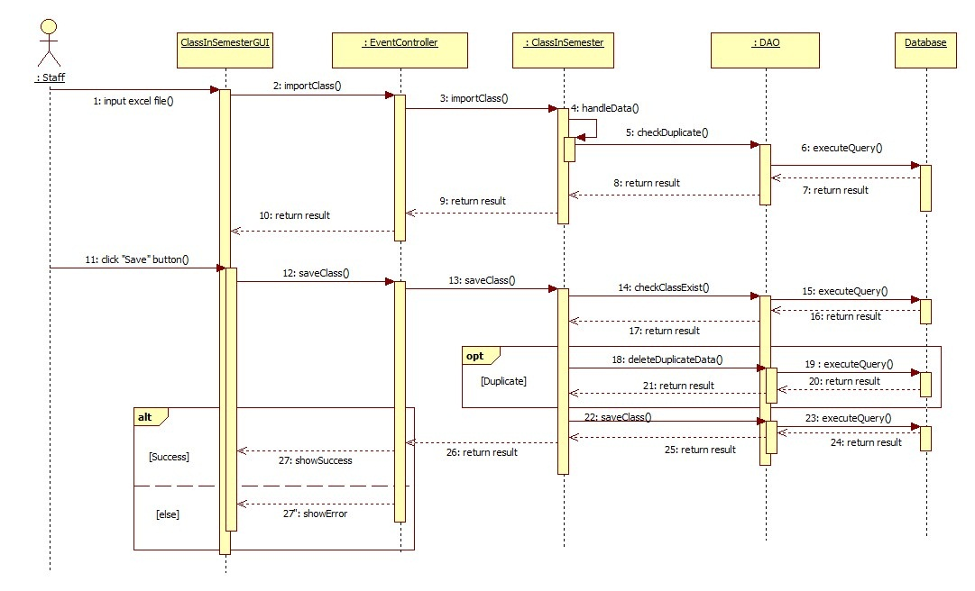

Figure : Sequence Diagram <Staff>Import Class in Semester

#### <Staff>Create Temporary Timetable

**Summary:** This diagram shows how system suggest temporary timetable.

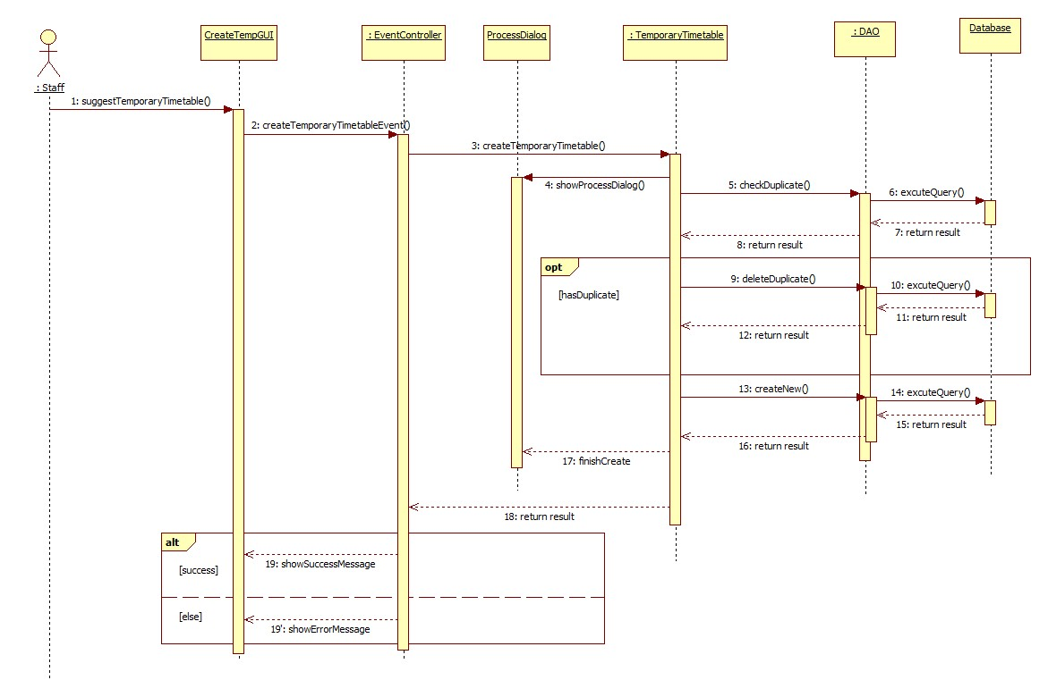

Figure : Sequence Diagram <Staff>Create Temporary Timetable

#### <Staff>View Temporary Timetable

**Summary:** This diagram shows how staff view temporary timetable.

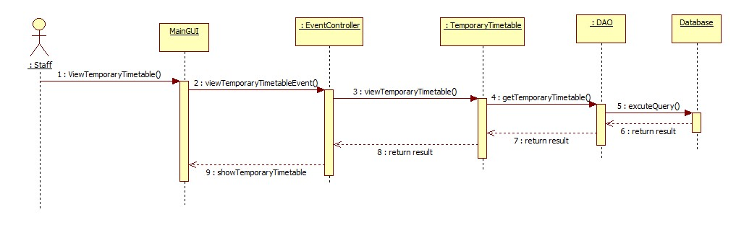

Figure : Sequence Diagram <Staff>View Temporary Timetable

#### <Staff>Edit Temporary Timetable

**Summary:** This diagram shows how staff edit temporary timetable.

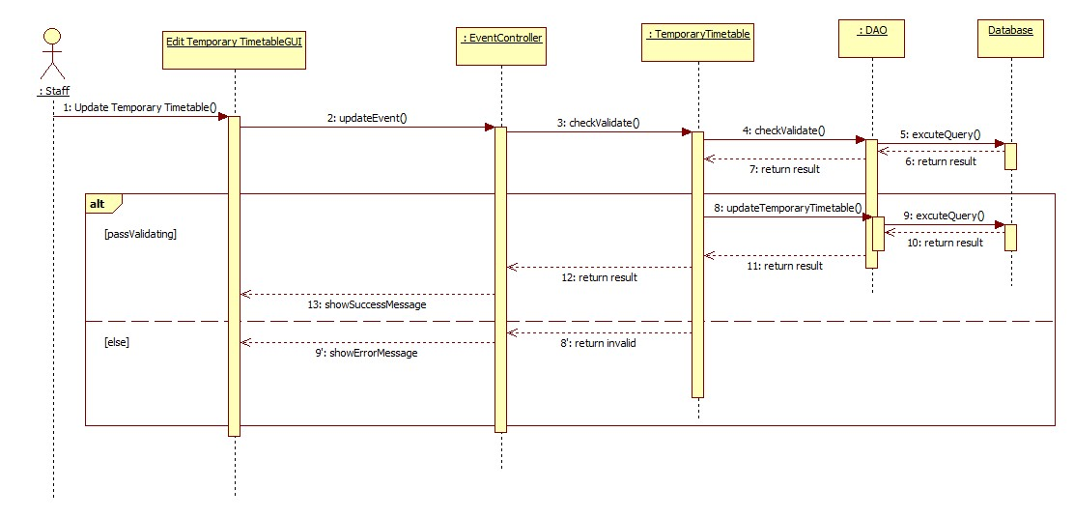

Figure : Sequence Diagram <Staff>Edit Temporary Timetable

#### <Staff>Export Temporary Timetable

**Summary:** This diagram shows how staff export temporary timetable to excel file.

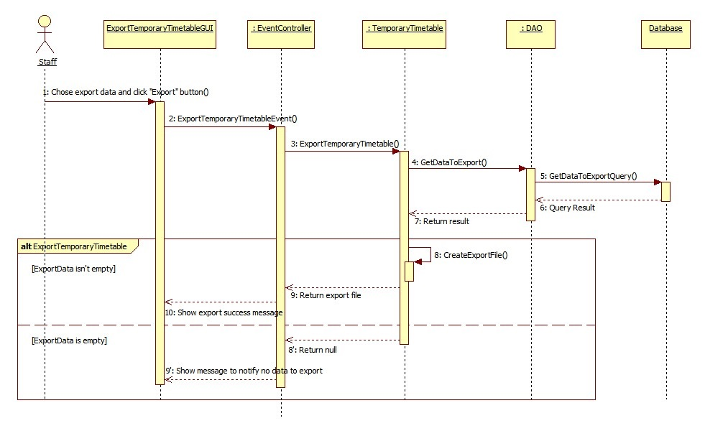

Figure : Sequence Diagram<Staff>Export Temporary Timetable

#### <Staff>Import Instructor List

**Summary:** This diagram shows how staff import instructor list into system.

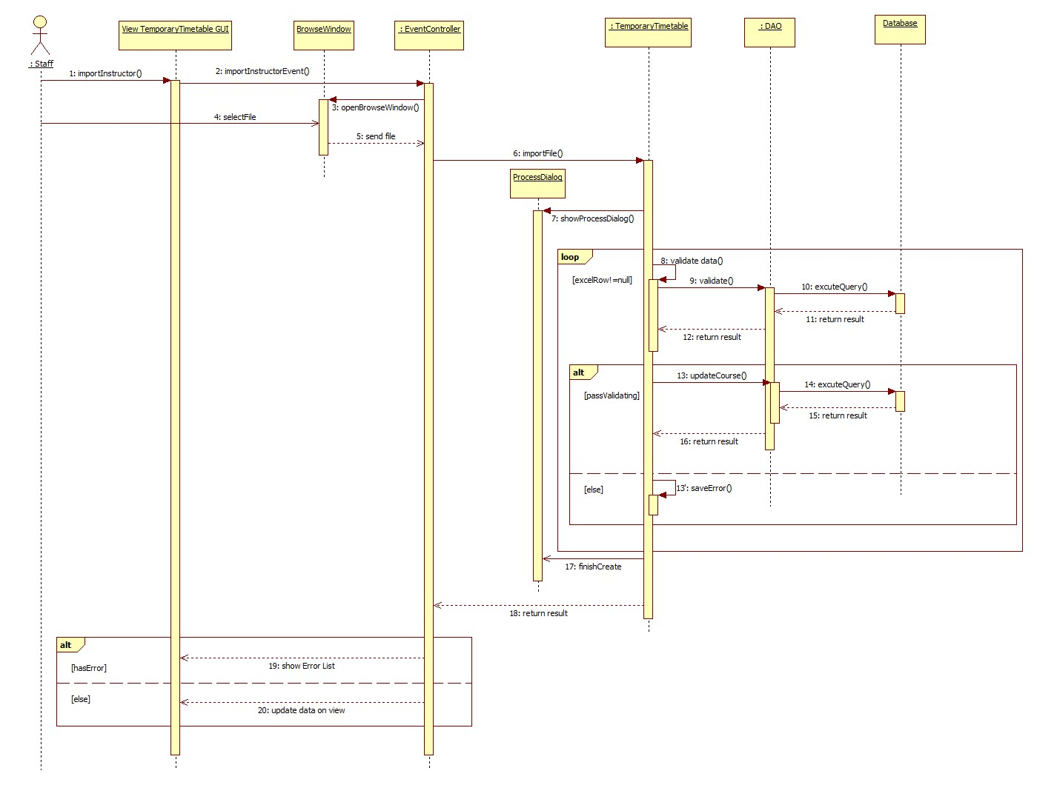

Figure : Sequence Diagram <Staff>Import Instructor List

#### <Staff>Check Conflict (Temporary Timetable)

**Summary:** This diagram shows how staff check conflict of temporary timetable

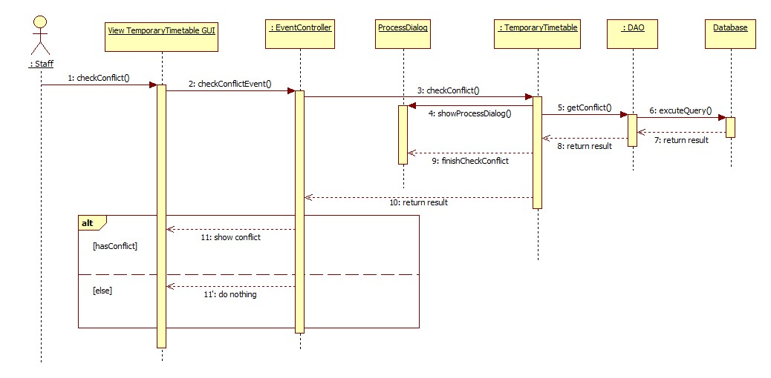

Figure : Sequence Diagram <Staff>Check Conflict (Temporary Timetable)

#### <Staff>Create Complete Timetable

**Summary:** This diagram shows how system suggest complete timetable from temporary timetable data

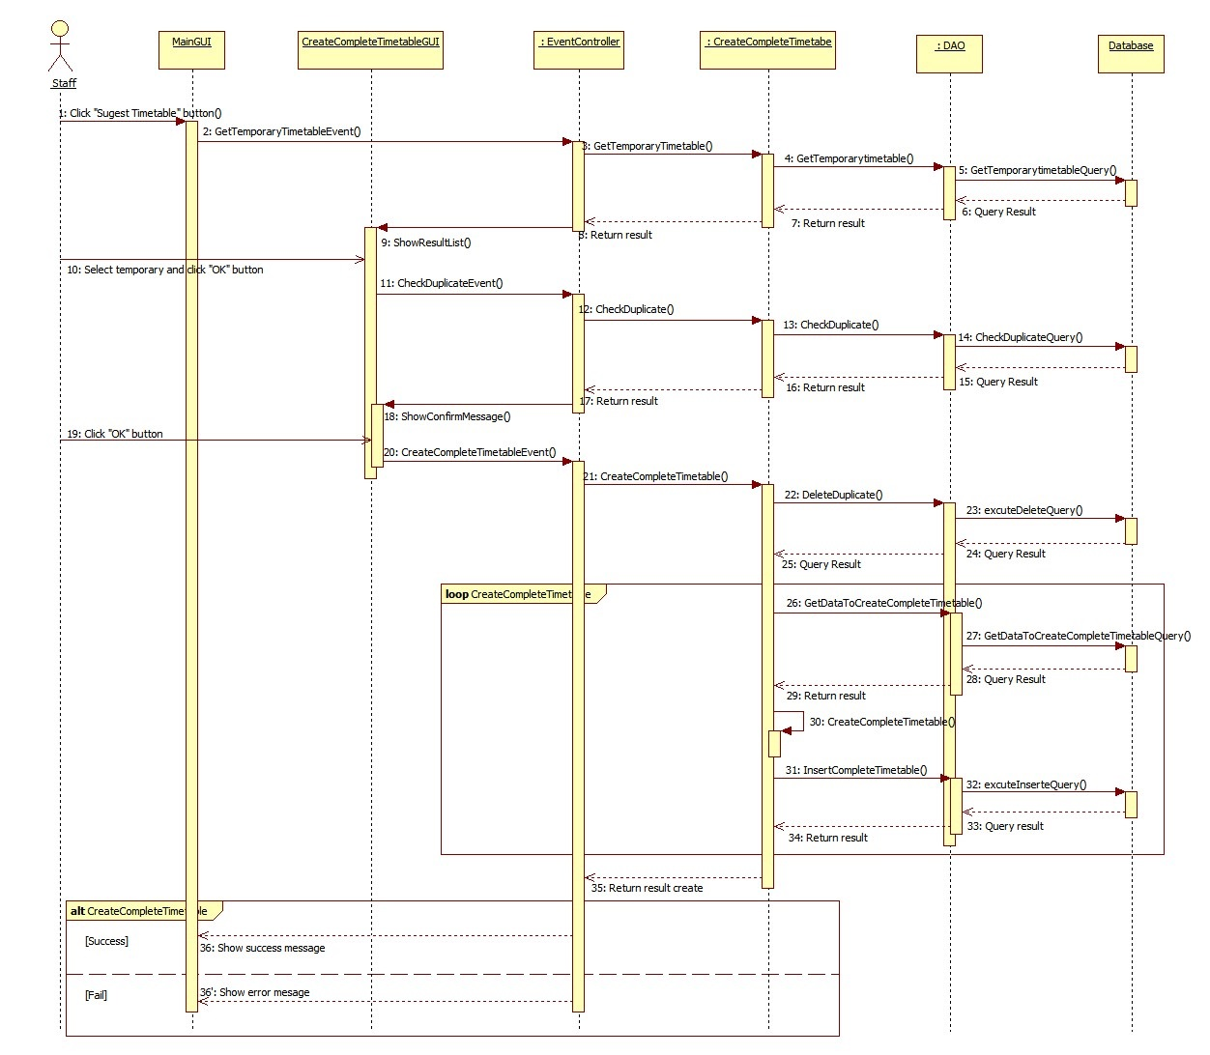

Figure : Sequence Diagram <Staff>Create Complete Timetable

#### <Staff>View Complete Timetable

**Summary:** This diagram shows how staff view complete timetable

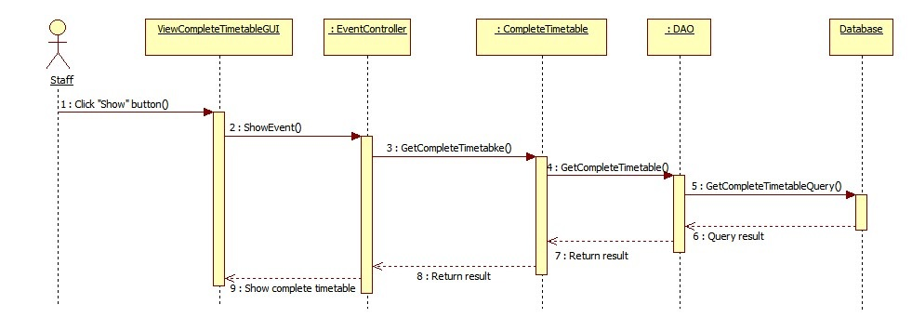

Figure : Sequence Diagram <Staff>View Complete Timetable

#### <Staff>Check Conflict (Complete Timetable)

**Summary:** This diagram shows how staff check conflict of complete timetable

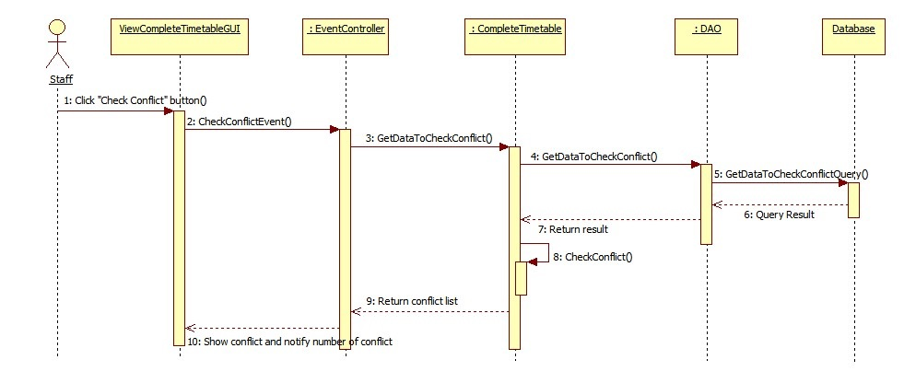

Figure : Sequence Diagram <Staff>Check Conflict (Complete Timetable)

#### <Staff>Export Complete Timetable

**Summary:** This diagram shows how staff export complete timetable to excel file

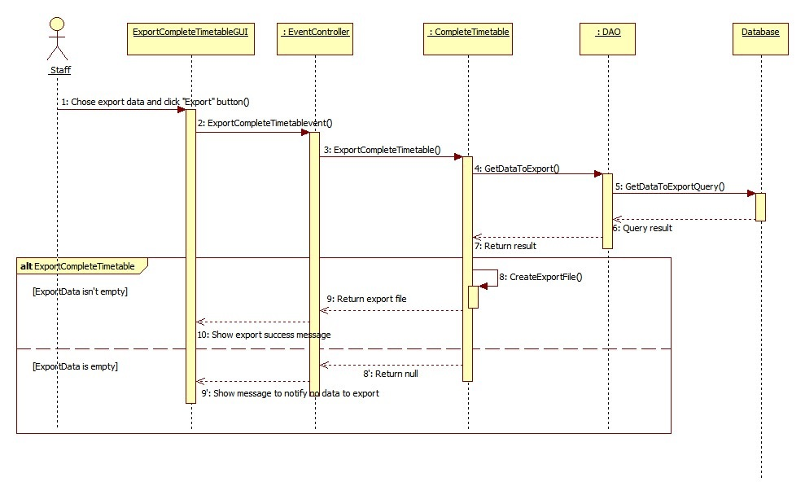

Figure : Sequence Diagram <Staff>Export Complete Timetable

#### <Staff>Edit Complete Timetable

**Summary:** This diagram shows how staff edit complete timetable

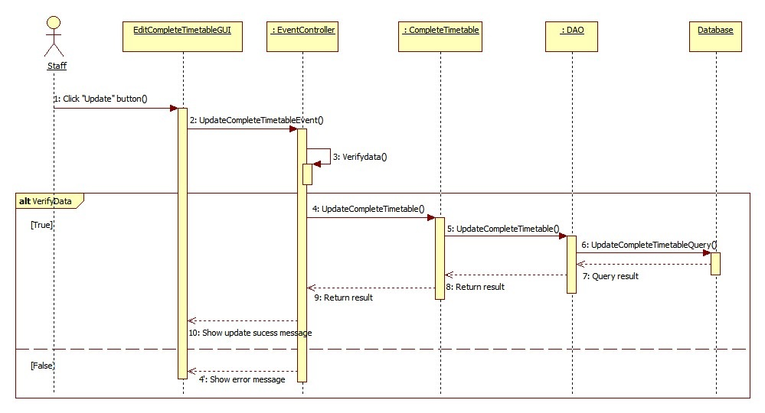

Figure : Sequence Diagram <Staff>Edit Complete Timetable

#### <Staff>Send Mail (Complete Timetable)

**Summary:** This diagram shows how staff send complete timetable to instructor’s mail

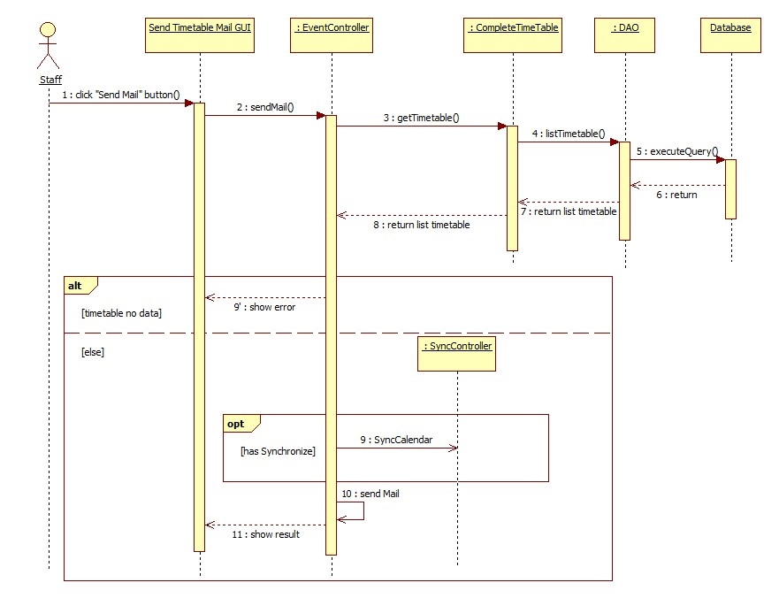

Figure : Sequence Diagram <Staff>Send Mail (Complete Timetable)

#### <Staff>Import Project Group

**Summary:** This diagram shows how staff import project group information into system

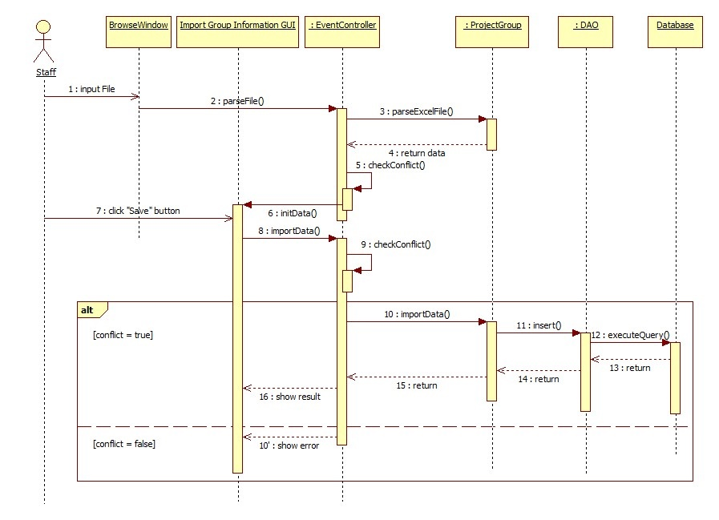

Figure : Sequence Diagram <Staff>Import Project Group

#### <Staff>Create Project Schedule

**Summary:** This diagram shows how staff suggest guild project schedule from complete timetable data

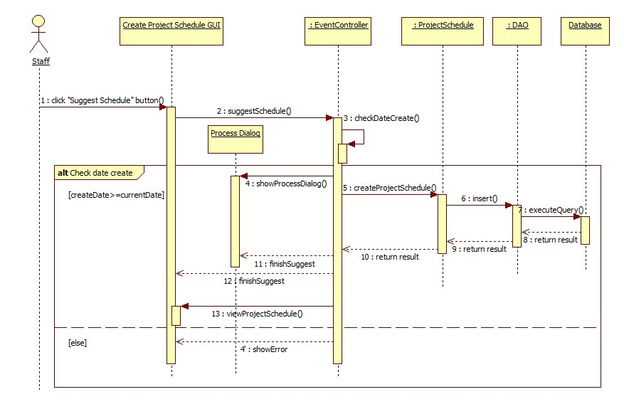

Figure : Sequence Diagram <Staff>Create Project Schedule

#### <Staff>Export Project Schedule

**Summary:** This diagram shows how staff export guild project schedule to excel file

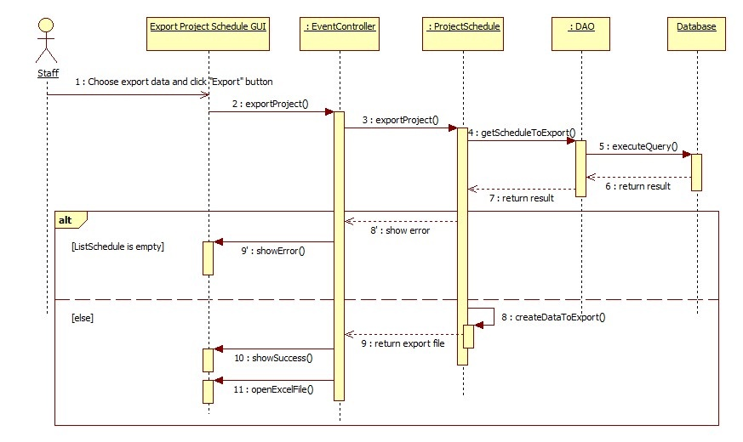

Figure : Sequence Diagram <Staff>Export Project Schedule

#### <Staff>Send Mail (Project Schedule)

**Summary:** This diagram shows how staff send guild project schedule to instructor’s mail

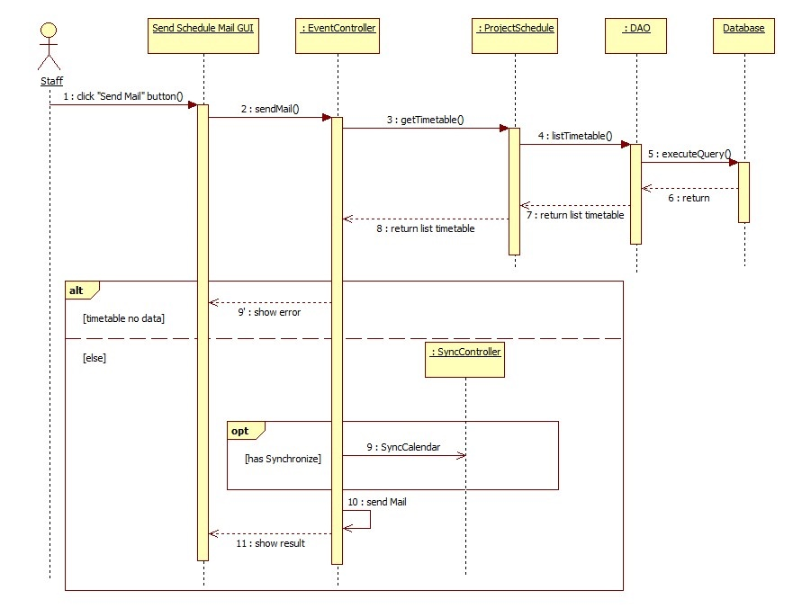

Figure : Sequence Diagram <Staff>Send Mail (Project Schedule)

#### <Staff>Calculate Timekeeping

**Summary:** This diagram shows how staff calculate timekeeping from complete timetable and guide project schedule data

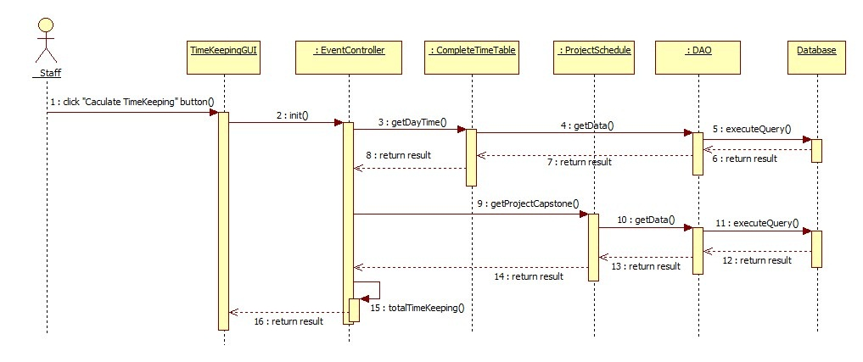

Figure : Sequence Diagram <Staff>Calculate Timekeeping

#### <Staff>Suggest Room

**Summary:** This diagram shows how staff suggest room for classes

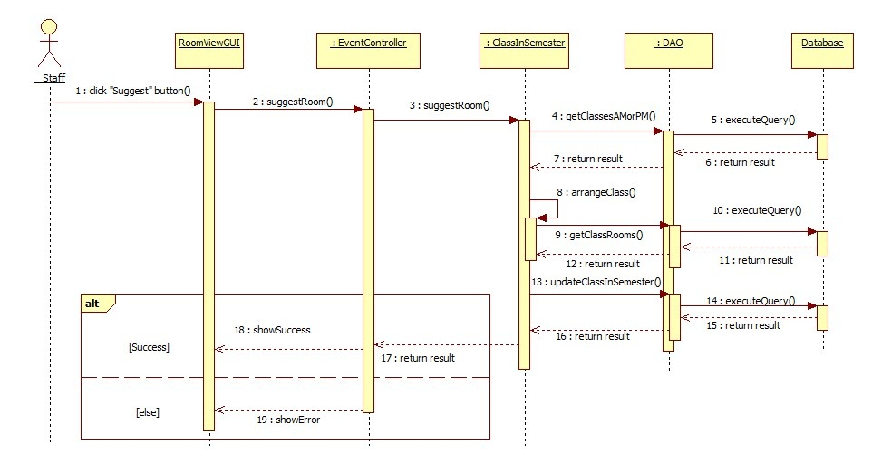

Figure : Sequence Diagram <Staff>Suggest Room

#### <Staff>Export Room Usage Schedule

**Summary:** This diagram shows how staff export room usage schedule to excel file

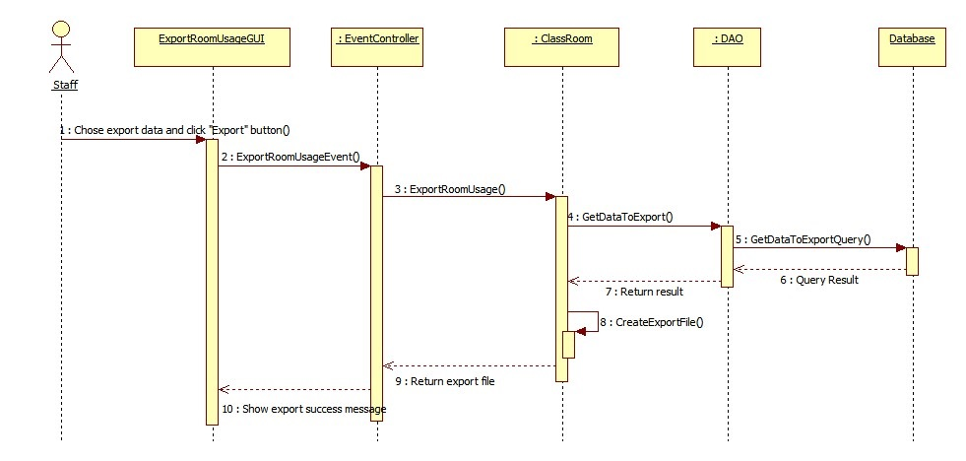

Figure : Sequence Diagram <Staff>Export Room Usage Schedule

#### <Staff>Send Mail (Time Keeping)

**Summary:** This diagram shows how staff send timekeeping to instructor mail 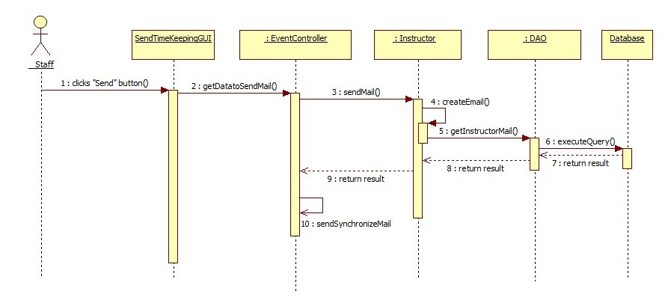

Figure : Sequence Diagram <Staff>Send Mail (Time Keeping)

## User Interface Design

### Guest Interface Design

#### Login

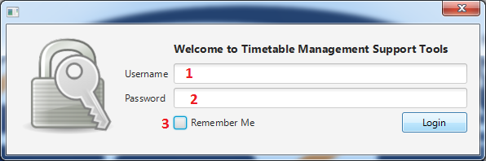

Figure : Login

**Fields**

|  |  |  |  |  |  |  |  |
| --- | --- | --- | --- | --- | --- | --- | --- |
| **No** | **Field**  **Name** | **Description** | **Read**  **only** | **Mandatory** | **Control**  **Type** | **Data**  **Type** | **Length** |
| 1 | Username | Fill username | No | Yes | Textbox | String | N/A |
| 2 | Password | Fill password | No | Yes | Password | String | N/A |
| 3 | Remember Me | Choose remember username and password mode | No | No | Checkbox | Boolean | N/A |

**Buttons**

|  |  |  |  |  |
| --- | --- | --- | --- | --- |
| **No** | **Function** | **Description** | **Validation** | **Outcome** |
| 4 | Login | Log-in into the system | N/A | Navigate to main window |

### Staff Interface Design

#### Create New Semester

##### Create New Semester Step 1

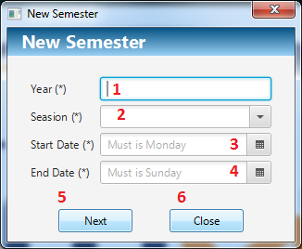

Figure : Create New Semester Step 1

**Fields**

|  |  |  |  |  |  |  |  |
| --- | --- | --- | --- | --- | --- | --- | --- |
| No | Field  Name | Description | Read  only | Mandatory | Control  Type | Data  Type | Length |
| 1 | Year | Fill username | No | Yes | Textbox | Integer | 4 |
| 2 | Season | Fill password | No | Yes | Combo box | String | N/A |
| 3 | Start Date | Pick start date | No | Yes | Date Picker | Date | N/A |
| 4 | End Date | Pick end date | No | Yes | Date Picker | Date | N/A |

**Buttons**

|  |  |  |  |  |
| --- | --- | --- | --- | --- |
| **No** | **Function** | **Description** | **Validation** | **Outcome** |
| 5 | Next | Go to next step to create new semester | N/A | Navigate to create new semester step 2 |
| 6 | Close | Click to close window | N/A | Close this window |

##### Create New Semester Step 2

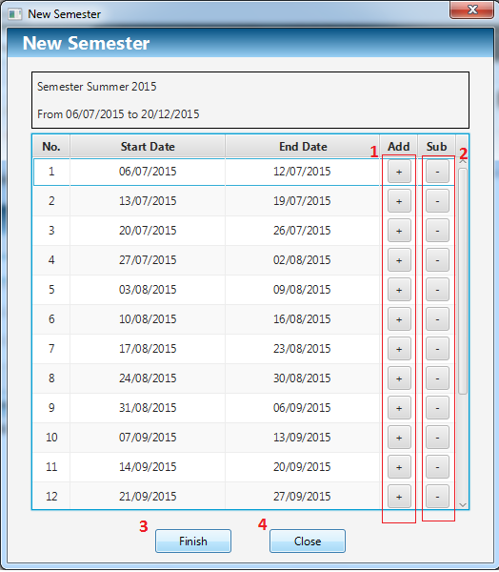

Figure : Create New Semester Step 2

**Buttons**

|  |  |  |  |  |
| --- | --- | --- | --- | --- |
| **No** | **Function** | **Description** | **Validation** | **Outcome** |
| 1 | Add | Increase start date and end date of this week as well as the week after it | N/A | Increase start date and end date of this week as well as the week after it |
| 2 | Sub | Decrease start date and end date of this week as well as the week before it | N/A | Decrease start date and end date of this week as well as the week before it |
| 3 | Finish | Add new semester into system | N/A | Create new semester, Choice this and close the window |
| 4 | Close | Click to close window | N/A | Close this window |

#### Chose Semester

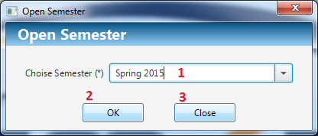

Figure : Chose Semester

**Fields**

|  |  |  |  |  |  |  |  |
| --- | --- | --- | --- | --- | --- | --- | --- |
| **No** | **Field**  **Name** | **Description** | **Read**  **only** | **Mandatory** | **Control**  **Type** | **Data**  **Type** | **Length** |
| 1 | Choice Semester | Choose semester want to process | No | Yes | Combo box | String | N/A |

**Buttons**

|  |  |  |  |  |
| --- | --- | --- | --- | --- |
| **No** | **Function** | **Description** | **Validation** | **Outcome** |
| 2 | Open | Open semester to process | N/A | Open this semester to process and close this window |
| 3 | Close | Click to close window | N/A | Close this window |

#### Import Plan Semester

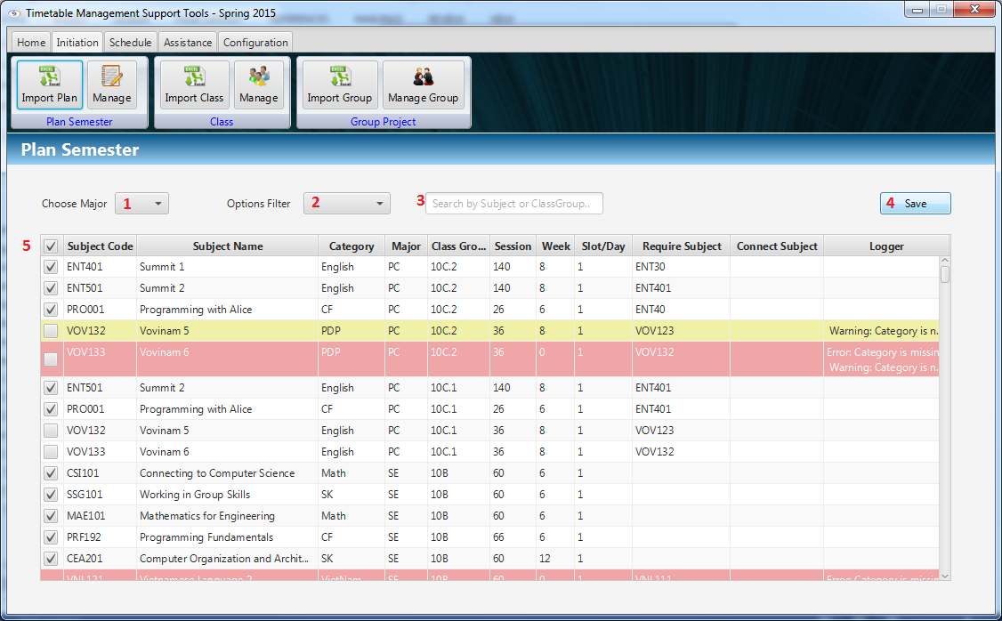

Figure : Import Plan Semester

**Fields**

|  |  |  |  |  |  |  |  |
| --- | --- | --- | --- | --- | --- | --- | --- |
| **No** | **Field**  **Name** | **Description** | **Read**  **only** | **Mandatory** | **Control**  **Type** | **Data**  **Type** | **Length** |
| 1 | Major | Filter data by major | No | No | Combo box | String | N/A |
| 2 | Options | Filter data by other options: Warning, Error and Over 6 Subjects | No | No | Combo box | String | N/A |
| 3 | Filter field | Filter data by subject or class group | No | No | Textbox | String | N/A |
| 5 | Check all | Check all row of table | No | No | Checkbox | Boolean | N/A |

**Buttons**

|  |  |  |  |  |
| --- | --- | --- | --- | --- |
| **No** | **Function** | **Description** | **Validation** | **Outcome** |
| 4 | Save | Save selected data from imported data | N/A | Save selected plan into system. |

#### Import Class

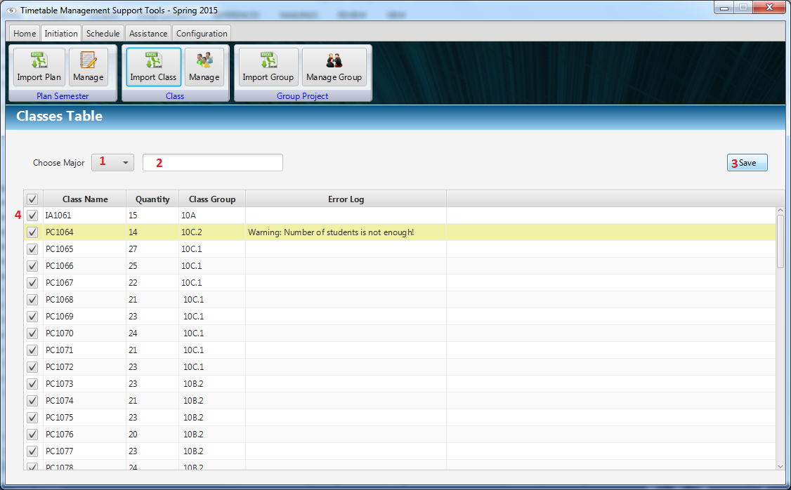

Figure : Import Plan Semester

**Fields**

|  |  |  |  |  |  |  |  |
| --- | --- | --- | --- | --- | --- | --- | --- |
| **No** | **Field**  **Name** | **Description** | **Read**  **only** | **Mandatory** | **Control**  **Type** | **Data**  **Type** | **Length** |
| 1 | Major | Filter imported data by major | No | No | Combo box | String | N/A |
| 2 | Filter field | Filter data by class or class group | No | No | Textbox | String | N/A |
| 4 | Check all | Check all row of table | No | No | Checkbox | Boolean | N/A |

**Buttons**

|  |  |  |  |  |
| --- | --- | --- | --- | --- |
| **No** | **Function** | **Description** | **Validation** | **Outcome** |
| 3 | Save | Save selected data from imported data | N/A | Save selected class into system. |

#### Suggest Temporary Timetable

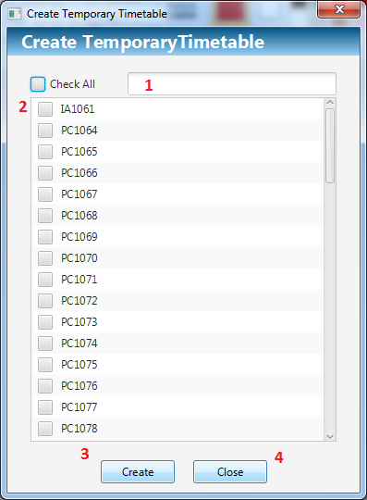

Figure : Suggest Temporary Timetable

**Fields**

|  |  |  |  |  |  |  |  |
| --- | --- | --- | --- | --- | --- | --- | --- |
| **No** | **Field**  **Name** | **Description** | **Read**  **only** | **Mandatory** | **Control**  **Type** | **Data**  **Type** | **Length** |
| 1 | Search | Fill search text | No | No | Textbox | String | N/A |
| 2 | Class Check List | Check class for create | No | Yes | Check List View | Boolean | N/A |

**Buttons**

|  |  |  |  |  |
| --- | --- | --- | --- | --- |
| **No** | **Function** | **Description** | **Validation** | **Outcome** |
| 3 | Create | Go to next step to create Temporary Timetable | N/A | Navigate to View Temporary Timetable |
| 4 | Close | Click to close window | N/A | Close this window |

#### Manage Temporary Timetable

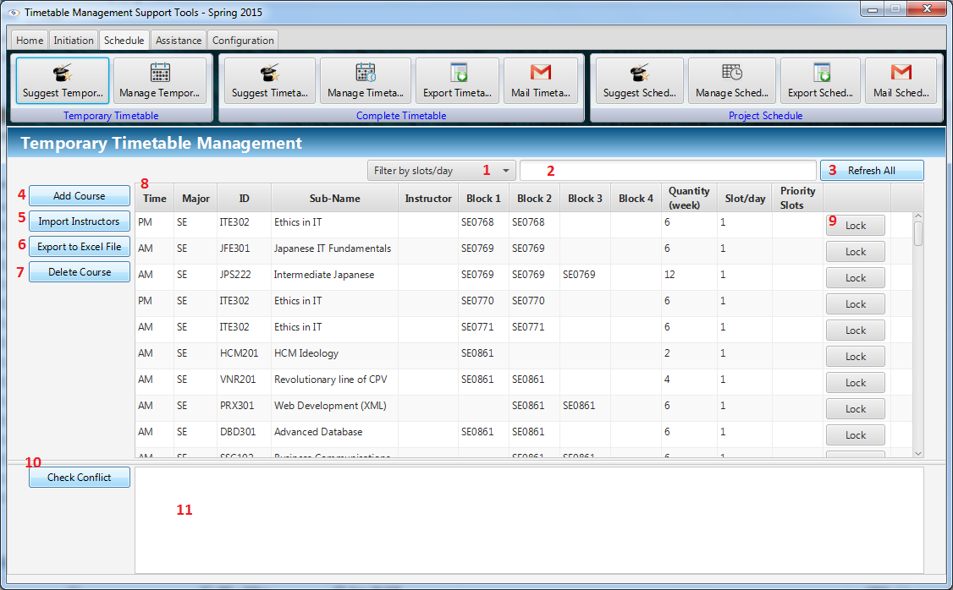

Figure : Manage Temporary Timetable

**Fields**

|  |  |  |  |  |  |  |  |
| --- | --- | --- | --- | --- | --- | --- | --- |
| **No** | **Field**  **Name** | **Description** | **Read**  **only** | **Mandatory** | **Control**  **Type** | **Data**  **Type** | **Length** |
| 1 | Filter | Filter data by slot per date. | Yes | No | Combo Box | String | N/A |
| 2 | Search | Fill search text. | No | No | Text Box | String | N/A |
| 8 | View Table | Display temporary timetable. | Yes | Yes | Table View | String, Integer | N/A |
| 11 | Conflict List View | Display conflict | Yes | No | List View | String | N/A |

**Buttons**

|  |  |  |  |  |
| --- | --- | --- | --- | --- |
| **No** | **Function** | **Description** | **Validation** | **Outcome** |
| 3 | Refresh All | Refresh Filter and Search to show all data of temporary timetable. | N/A | Refresh data presenting on Table View. |
| 4 | Add Course | Go to next step to add new course into temporary timetable | N/A | Open to Add New Course window. |
| 5 | Import Instructors | Go to next step to import instructor list. | N/A | Open File Choosers window to import instructors. |
| 6 | Export To Excel File | Go to next step to export temporary timetable to excel file. | N/A | Open to Export Temporary Timetable window. |
| 7 | Delete Course | Go to next step to delete course which is presented by specific selected row in Table View. | N/A | Show confirm message |
| 9 | Lock | Lock the row contains it to prevent double click (Double click to start Edit Course function). | N/A | Lock the container row. |
| 10 | Check Conflict | Check conflict temporary timetable data. | N/A | Show conflicts in Conflict List View |

#### Add course

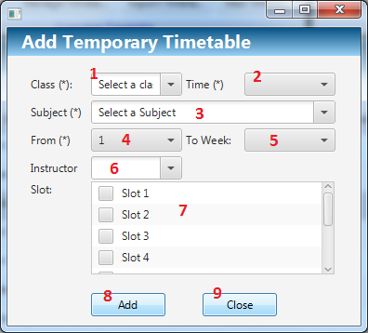

Figure : Add course

**Fields**

|  |  |  |  |  |  |  |  |
| --- | --- | --- | --- | --- | --- | --- | --- |
| **No** | **Field**  **Name** | **Description** | **Read**  **only** | **Mandatory** | **Control**  **Type** | **Data**  **Type** | **Length** |
| 1 | Class | Select class to add | No | Yes | Combo Box | String | N/A |
| 2 | Time | Select AM or PM | No | Yes | Combo Box | String | N/A |
| 3 | Subject | Select Subject to add | No | Yes | Combo Box | String | N/A |
| 4 | From Week | Select Start Week | No | Yes | Combo Box | Integer | N/A |
| 5 | End Week | Display End Week associated with selected End Week and Subject | Yes | Yes | Combo Box | Integer | N/A |
| 6 | Instructor | Select Instructor to add | No | No | Combo Box | String | N/A |
| 7 | Slot List View | Check the priority slots if need. | No | No | Check List View | Boolean | N/A |

**Buttons**

|  |  |  |  |  |
| --- | --- | --- | --- | --- |
| **No** | **Function** | **Description** | **Validation** | **Outcome** |
| 8 | Add | Add new course into system | N/A | Add new course into system and close window |
| 9 | Close | Click to close window | N/A | Close this window |

#### Edit Temporary Timetable

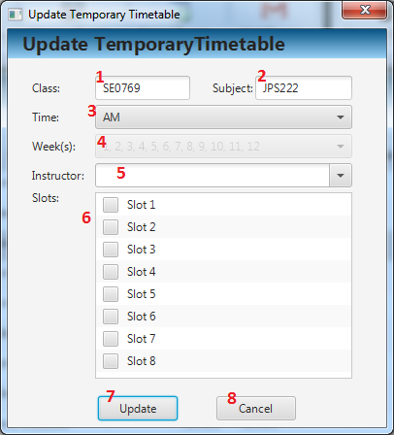

Figure : Edit Temporary Timetable

**Fields**

|  |  |  |  |  |  |  |  |
| --- | --- | --- | --- | --- | --- | --- | --- |
| **No** | **Field**  **Name** | **Description** | **Read**  **only** | **Mandatory** | **Control**  **Type** | **Data**  **Type** | **Length** |
| 1 | Class | Select class to edit | No | Yes | Combo Box | String | N/A |
| 2 | Time | Select AM or PM | No | Yes | Combo Box | String | N/A |
| 3 | Subject | Select Subject to edit | No | Yes | Combo Box | String | N/A |
| 4 | From Week | Select assigned weeks | No | Yes | Combo Box | Integer | N/A |
| 5 | Instructor | Select Instructor to edit. | No | No | Combo Box | String | N/A |
| 6 | Slot List View | Check the priority slots if need. | No | No | Check List View | Boolean | N/A |

**Buttons**

|  |  |  |  |  |
| --- | --- | --- | --- | --- |
| **No** | **Function** | **Description** | **Validation** | **Outcome** |
| 7 | Edit | Click to go to next step to edit course | N/A | New course is add to temporary timetable |
| 8 | Cancel | Click to cancel and close window | N/A | Close this window |

#### Export Temporary Timetable

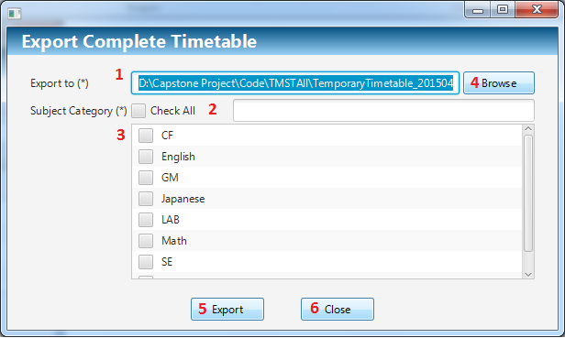

Figure : Export Temporary Timetable

**Fields**

|  |  |  |  |  |  |  |  |
| --- | --- | --- | --- | --- | --- | --- | --- |
| **No** | **Field**  **Name** | **Description** | **Read**  **only** | **Mandatory** | **Control**  **Type** | **Data**  **Type** | **Length** |
| 1 | Url Text Box | Display url path | No | Yes | Text Box | String | N/A |
| 2 | Search | Input search text | No | No | Text Box | String | N/A |
| 3 | Category | Seleck Major to export | No | Yes | Check List View | Boolean | N/A |

**Buttons**

|  |  |  |  |  |
| --- | --- | --- | --- | --- |
| **No** | **Function** | **Description** | **Validation** | **Outcome** |
| 4 | Browse | Click to choose URL path | N/A | URL path is show in URL path text box |
| 5 | Export | Click to export to excel file | N/A | Temporary Timetable is export. |
| 6 | Cancel | Click to cancel and close window | N/A | Close this window |

#### Suggest Complete Timetable

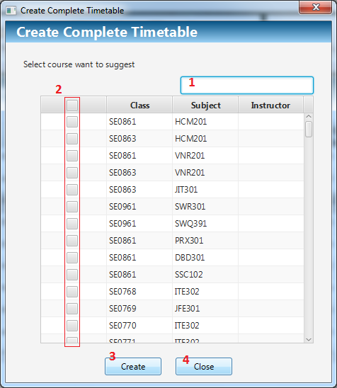

Figure : Suggest Complete Timetable

**Fields**

|  |  |  |  |  |  |  |  |
| --- | --- | --- | --- | --- | --- | --- | --- |
| **No** | **Field**  **Name** | **Description** | **Read**  **only** | **Mandatory** | **Control**  **Type** | **Data**  **Type** | **Length** |
| 1 | Filter | Fill filter | No | No | Textbox | String | N/A |
| 2 | N/A | Choice the course want to suggest complete timetable | No | Yes | Checklist View | Boolean | N/A |

**Buttons**

|  |  |  |  |  |
| --- | --- | --- | --- | --- |
| **No** | **Function** | **Description** | **Validation** | **Outcome** |
| 3 | Create | Suggest complete timetable | N/A | Suggest complete timetable for selected course and close window |
| 4 | Close | Click to close window | N/A | Close this window |

#### Manage Complete Timetable

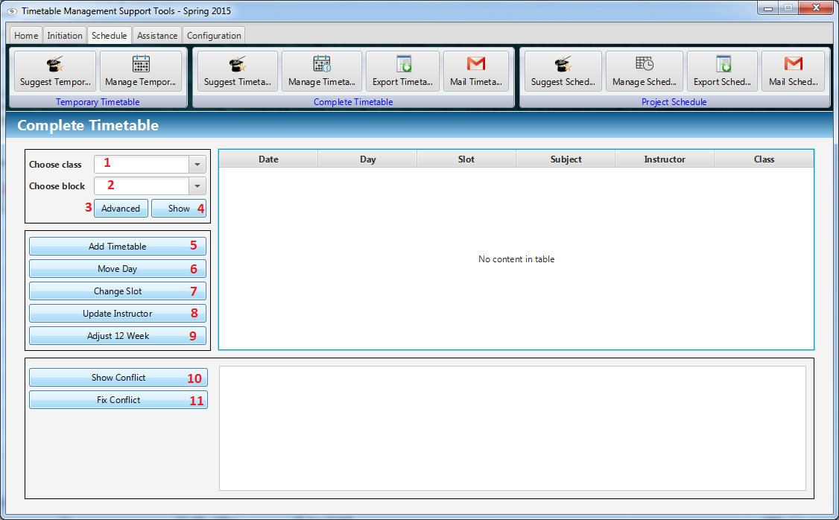

Figure : Manage Complete Timetable

**Fields**

|  |  |  |  |  |  |  |  |
| --- | --- | --- | --- | --- | --- | --- | --- |
| **No** | **Field**  **Name** | **Description** | **Read**  **only** | **Mandatory** | **Control**  **Type** | **Data**  **Type** | **Length** |
| 1 | Choose class | Choice the class want to view complete timetable | No | No | Combo box | String | N/A |
| 2 | Choose block | Choice the block want to view complete timetable | No | Yes | Combo box | String | N/A |

**Buttons**

|  |  |  |  |  |
| --- | --- | --- | --- | --- |
| **No** | **Function** | **Description** | **Validation** | **Outcome** |
| 3 | Advanced | Open search advanced window | N/A | Open search advanced window |
| 4 | Show | Show complete timetable in table view | N/A | Show complete timetable in table view |
| 5 | Add timetable | Open add timetable window | N/A | Open add timetable window |
| 6 | Move Day | Open move day window | N/A | Open move day window |
| 7 | Change Slot | Open change slot window | N/A | Open change slot window |
| 8 | Update Instructor | Open update instructor window | N/A | Open update instructor window |
| 9 | Adjust 12 Weeks | Open adjust 12 weeks window | N/A | Open adjust 12 weeks window |
| 10 | Show Conflict | Show conflict in list view | N/A | Show conflict in list view |
| 11 | Fix Conflict | Depending on conflict type, system open window to fix conflict | N/A | Depending on conflict type, system open window to fix conflict |

#### Add Complete Timetable

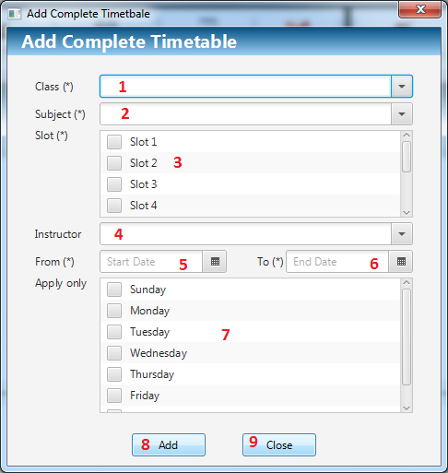

Figure : Add Complete Timetable

**Fields**

|  |  |  |  |  |  |  |  |
| --- | --- | --- | --- | --- | --- | --- | --- |
| **No** | **Field**  **Name** | **Description** | **Read**  **only** | **Mandatory** | **Control**  **Type** | **Data**  **Type** | **Length** |
| 1 | Class | Choice the class | No | Yes | Combo box | String | N/A |
| 2 | Subject | Choice the subject | No | Yes | Combo box | String | N/A |
| 3 | Slot | Choice the slot | No | Yes | Checklist View | Boolean | N/A |
| 4 | Instructor | Choice the instructor | No | No | Combo box | String | N/A |
| 5 | Start Date | Pick start date | No | Yes | Date Picker | Date | N/A |
| 6 | End Date | Pick end date | No | Yes | Date Picker | Date | N/A |
| 7 | Apply only | Choice apply only day in week | No | No | Checklist View | String | N/A |

**Buttons**

|  |  |  |  |  |
| --- | --- | --- | --- | --- |
| **No** | **Function** | **Description** | **Validation** | **Outcome** |
| 8 | Add | Add new complete timetable | N/A | Add new complete timetable and close this window |
| 9 | Close | Click to close window | N/A | Close this window |

#### Change Slot

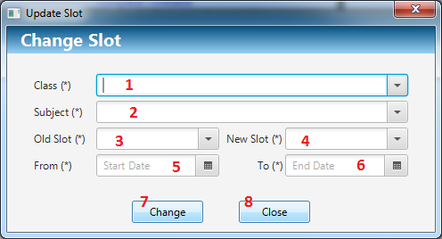

Figure : Change Slot

**Fields**

|  |  |  |  |  |  |  |  |
| --- | --- | --- | --- | --- | --- | --- | --- |
| **No** | **Field**  **Name** | **Description** | **Read**  **only** | **Mandatory** | **Control**  **Type** | **Data**  **Type** | **Length** |
| 1 | Class | Choice the class | No | Yes | Combo box | String | N/A |
| 2 | Subject | Choice the subject | No | Yes | Combo box | String | N/A |
| 3 | Old Slot | Choice the old slot | No | Yes | Combo box | Integer | N/A |
| 4 | New Slot | Choice the new slot | No | Yes | Combo box | Integer | N/A |
| 5 | Start Date | Pick start date | No | Yes | Date Picker | Date | N/A |
| 6 | End Date | Pick end date | No | Yes | Date Picker | Date | N/A |

**Buttons**

|  |  |  |  |  |
| --- | --- | --- | --- | --- |
| **No** | **Function** | **Description** | **Validation** | **Outcome** |
| 7 | Change | Change slot of complete timetable from old slot to new slot in start date to end date | N/A | Change slot of complete timetable from old slot to new slot in start date to end date and close this window |
| 8 | Close | Click to close window | N/A | Close this window |

#### Update Instructor

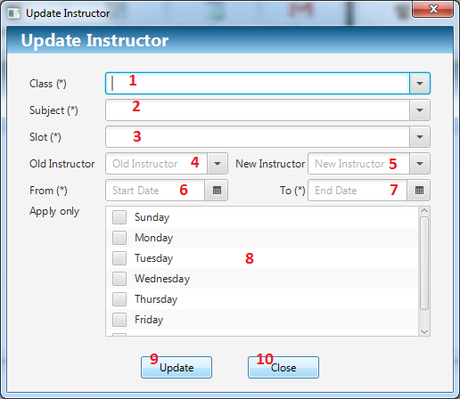

Figure : Update Instructor

**Fields**

|  |  |  |  |  |  |  |  |
| --- | --- | --- | --- | --- | --- | --- | --- |
| **No** | **Field**  **Name** | **Description** | **Read**  **only** | **Mandatory** | **Control**  **Type** | **Data**  **Type** | **Length** |
| 1 | Class | Choice the class | No | Yes | Combo box | String | N/A |
| 2 | Subject | Choice the subject | No | Yes | Combo box | String | N/A |
| 3 | Slot | Choice the slot | No | Yes | Combo box | Integer | N/A |
| 4 | Old Instructor | Choice the old instructor | No | No | Combo box | String | N/A |
| 5 | New Instructor | Choice the new instructor | No | No | Combo box | String | N/A |
| 6 | Start Date | Pick start date | No | Yes | Date Picker | Date | N/A |
| 7 | End Date | Pick end date | No | Yes | Date Picker | Date | N/A |
| 8 | Apply only | Choice apply only day in week | No | No | Checklist View | String | N/A |

**Buttons**

|  |  |  |  |  |
| --- | --- | --- | --- | --- |
| **No** | **Function** | **Description** | **Validation** | **Outcome** |
| 9 | Update | Update instructor from old instructor to new instructor | N/A | Update instructor from old instructor to new instructor and close window |
| 10 | Close | Click to close window | N/A | Close this window |

#### Move Date

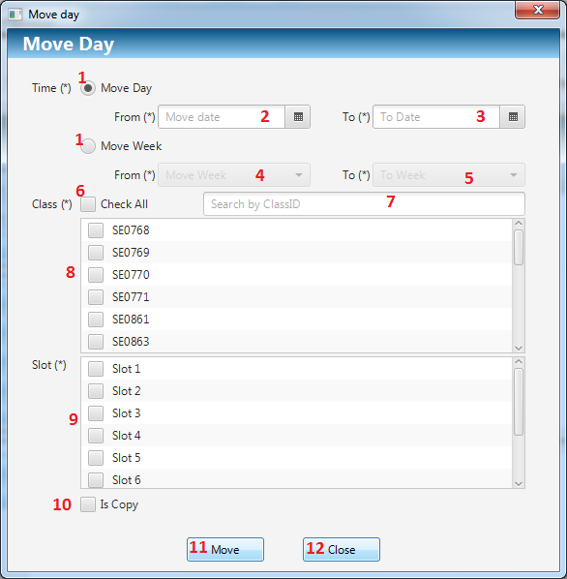

Figure : Move Date

**Fields**

|  |  |  |  |  |  |  |  |
| --- | --- | --- | --- | --- | --- | --- | --- |
| **No** | **Field**  **Name** | **Description** | **Read**  **only** | **Mandatory** | **Control**  **Type** | **Data**  **Type** | **Length** |
| 1 | Time | Choice move mode | No | Yes | Radio button | String | N/A |
| 2 | Start Date | Pick start date | No | Yes | Date Picker | Date | N/A |
| 3 | End Date | Pick end date | No | Yes | Date Picker | Date | N/A |
| 4 | Start Week | Choice start week | No | Yes | Combo box | Integer | N/A |
| 5 | End Week | Choice end week | No | Yes | Combo box | Integer | N/A |
| 6 | Check All | Check all/Uncheck all class | No | No | Date Picker | Date | N/A |
| 7 | Filter | Fill filter to filter data | No | No | Textbox | String | N/A |
| 8 | Class | Choice class | No | Yes | Checklist View | Boolean | N/A |
| 9 | Slot | Choice slot | No | Yes | Checklist View | Boolean | N/A |
| 10 | Is copy | Choice is copy mode | No | No | Checkbox | Boolean | N/A |

**Buttons**

|  |  |  |  |  |
| --- | --- | --- | --- | --- |
| **No** | **Function** | **Description** | **Validation** | **Outcome** |
| 11 | Move | Move complete timetable from start date to end date as well as start week to end week | N/A | Move complete timetable and close this window |
| 12 | Close | Click to close window | N/A | Close this window |

#### Delete Complete Timetable

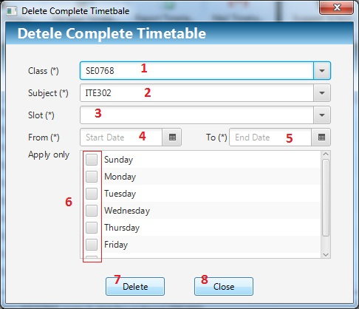

Figure : Delete Complete Timetable

**Fields**

|  |  |  |  |  |  |  |  |
| --- | --- | --- | --- | --- | --- | --- | --- |
| **No** | **Field**  **Name** | **Description** | **Read**  **only** | **Mandatory** | **Control**  **Type** | **Data**  **Type** | **Length** |
| 1 | Class | Choice the class | No | Yes | Combo box | String | N/A |
| 2 | Subject | Choice the subject | No | Yes | Combo box | String | N/A |
| 3 | Slot | Choice the slot | No | Yes | Combo box | Integer | N/A |
| 4 | Start Date | Pick start date | No | Yes | Date Picker | Date | N/A |
| 5 | End Date | Pick end date | No | Yes | Date Picker | Date | N/A |
| 6 | Apply only | Choice apply only day in week | No | No | Checklist View | String | N/A |

**Buttons**

|  |  |  |  |  |
| --- | --- | --- | --- | --- |
| No | Function | Description | Validation | Outcome |
| 7 | Delete | Delete complete timetable which satisfy conditions | N/A | Delete complete timetable which satisfy conditions and close window |
| 8 | Close | Click to close window | N/A | Close this window |

#### Adjust 12 Weeks

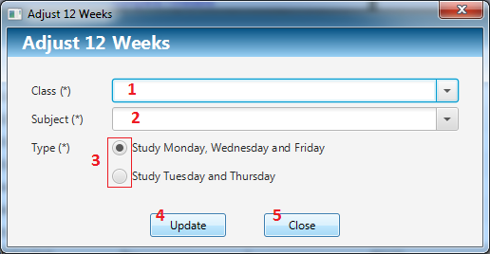

Figure : Adjust 12 Weeks

**Fields**

|  |  |  |  |  |  |  |  |
| --- | --- | --- | --- | --- | --- | --- | --- |
| **8** | **Close** | **Click to close window** | **N/A** | **Close this window** | **8** | **Close** | **Click to close window** |
| 1 | Class | Choice the class | No | Yes | Combo box | String | N/A |
| 2 | Subject | Choice the subject | No | Yes | Combo box | String | N/A |
| 3 | Type | Choice adjust type | No | Yes | Radio button | Integer | N/A |

**Buttons**

|  |  |  |  |  |
| --- | --- | --- | --- | --- |
| **No** | **Function** | **Description** | **Validation** | **Outcome** |
| 4 | Update | Adjust complete timetable for subject 12 weeks | N/A | Adjust complete timetable and close window |
| 5 | Close | Click to close window | N/A | Close this window |

#### Export Complete Timetable

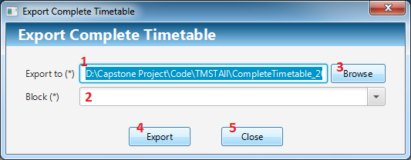

Figure : Export Complete Timetable

**Fields**

|  |  |  |  |  |  |  |  |
| --- | --- | --- | --- | --- | --- | --- | --- |
| **No** | **Field**  **Name** | **Description** | **Read**  **only** | **Mandatory** | **Control**  **Type** | **Data**  **Type** | **Length** |
| 1 | Export to | File path | Yes | Yes | Textbox | String | N/A |
| 2 | Block | Choice the block | No | Yes | Combo box | Integer | N/A |

**Buttons**

|  |  |  |  |  |
| --- | --- | --- | --- | --- |
| **No** | **Function** | **Description** | **Validation** | **Outcome** |
| 3 | Browse | Open file chooser window | N/A | Open file chooser window |
| 4 | Export | Export complete timetable to file path | N/A | Export complete timetable and close window |
| 5 | Close | Click to close window | N/A | Close this window |

#### Send Mail (Complete Timetable)

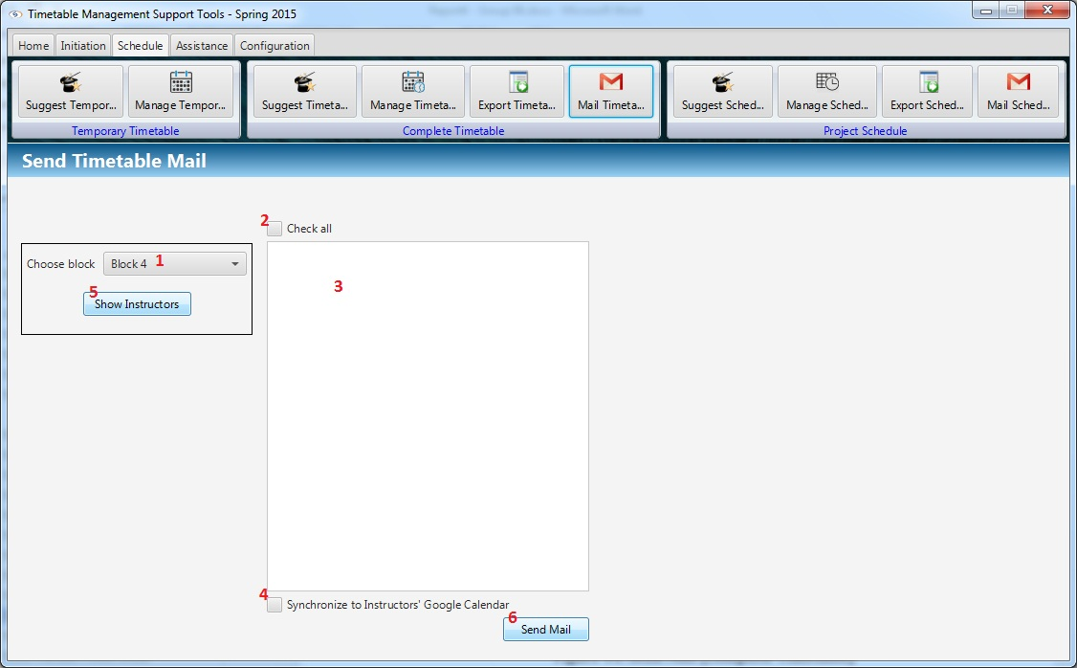

Figure : Send Mail (Complete Timetable)

**Fields**

|  |  |  |  |  |  |  |  |
| --- | --- | --- | --- | --- | --- | --- | --- |
| **No** | **Field**  **Name** | **Description** | **Read**  **only** | **Mandatory** | **Control**  **Type** | **Data**  **Type** | **Length** |
| 1 | Block | Choice the block | No | Yes | Combo box | String | N/A |
| 2 | Check all | Check all instructor in list view | No | No | Check box | Boolean | N/A |
| 3 | List Instructors | View instructors in a block | No | No | Checklist View | String | N/A |
| 4 | Synchronize | Synchronize timetable with Google Calendar | No | No | Check box | Boolean | N/A |

**Buttons**

|  |  |  |  |  |
| --- | --- | --- | --- | --- |
| No | Function | Description | Validation | Outcome |
| 5 | Show Instructors | Show instructors have class in block. | N/A | Show instructors have class in block and checked |
| 6 | Send Mail | Send timetable to instructor’s mail. | N/A | Send timetable to instructor’s mail. Synchronize with Google Calendar if Synchronize check box is selected. |

#### Import Project Group

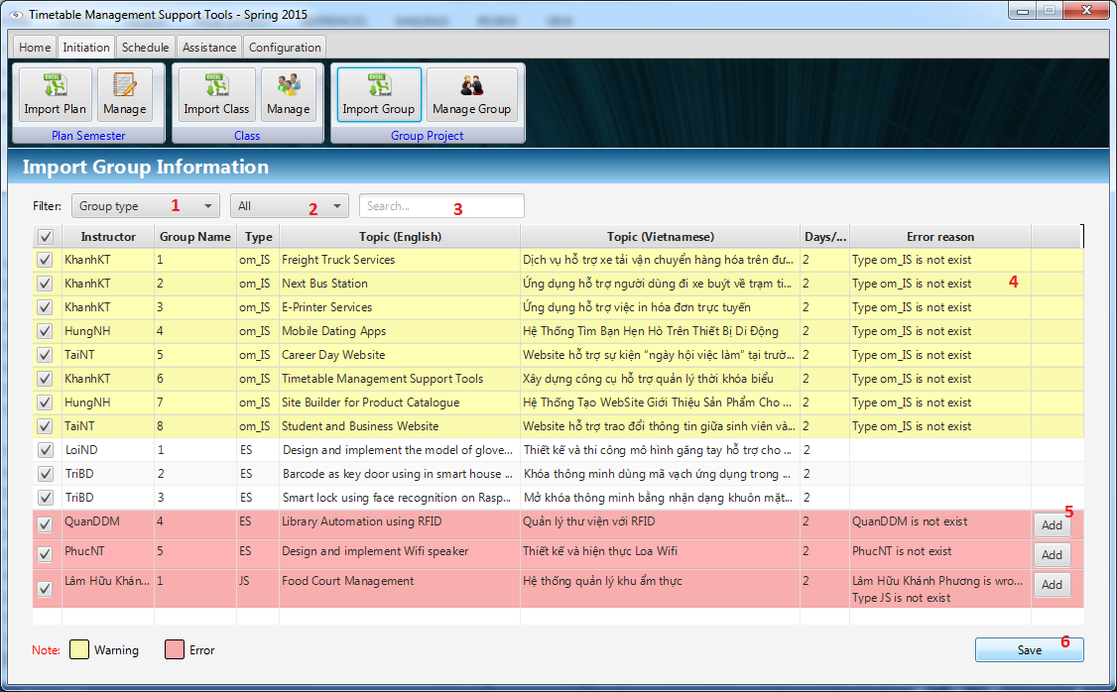

Figure : Import Project Group

**Fields**

|  |  |  |  |  |  |  |  |
| --- | --- | --- | --- | --- | --- | --- | --- |
| **No** | **Field**  **Name** | **Description** | **Read**  **only** | **Mandatory** | **Control**  **Type** | **Data**  **Type** | **Length** |
| 1 | Group Type | Filter by group type | No | No | Combo box | String | N/A |
| 2 | Error | Filter by error row or warning row | No | No | Combo box | String | N/A |
| 3 | Search | Filter by input text | No | No | Text Field | String | N/A |
| 4 | View data | Display parsed data from excel. | Yes | No | Table View | String | N/A |

**Buttons**

|  |  |  |  |  |
| --- | --- | --- | --- | --- |
| No | Function | Description | Validation | Outcome |
| 5 | Add instructor | Add information of an instructor. | N/A | Add information of an instructor if this instructor is not exist in system |
| 6 | Save | Save data from table view to system. | N/A | Save data from table view to system. |

#### Manage Project Group

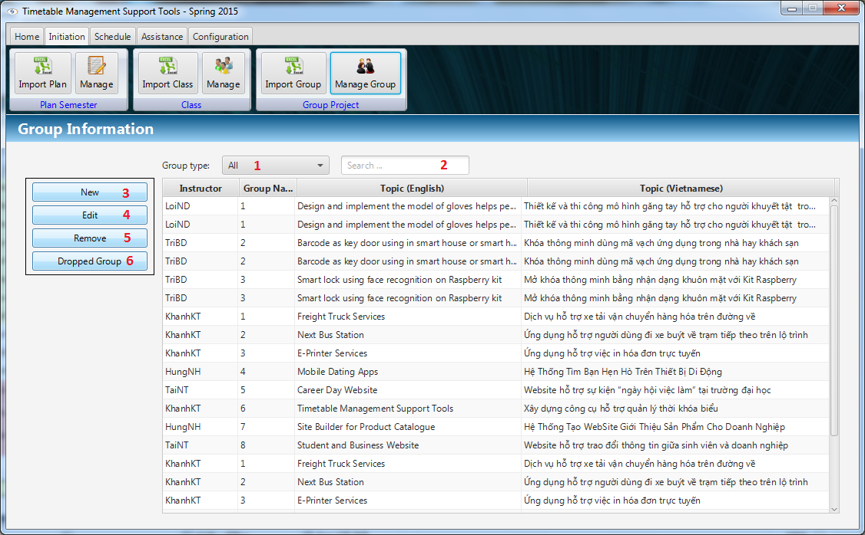

Figure : Manage Project Group

**Fields**

|  |  |  |  |  |  |  |  |
| --- | --- | --- | --- | --- | --- | --- | --- |
| **No** | **Field**  **Name** | **Description** | **Read**  **only** | **Mandatory** | **Control**  **Type** | **Data**  **Type** | **Length** |
| 1 | Group Type | Filter by group type | No | No | Combo box | String | N/A |
| 2 | Search | Filter by input text | No | No | Text Field | String | N/A |
| 3 | View data | Display information of each group on table view | Yes | No | Table View | String | N/A |

**Buttons**

|  |  |  |  |  |
| --- | --- | --- | --- | --- |
| No | Function | Description | Validation | Outcome |
| 4 | New | Add new group | N/A | Add new group to system and show on table view. |
| 5 | Edit | Update new information of selected group. | N/A | Update new information of selected group. |
| 6 | Remove | Remove selected group on table view. | N/A | Remove selected group on table view. |
| 7 | Dropped Group | Set date drop for group has been dropped. | N/A | Set date drop for group has been dropped and remove schedules after date drop. |

#### Suggest Project Schedule

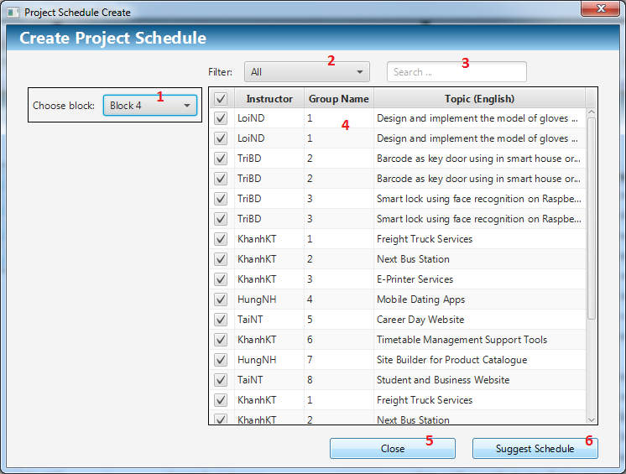

Figure : Suggest Project Schedule

**Fields**

|  |  |  |  |  |  |  |  |
| --- | --- | --- | --- | --- | --- | --- | --- |
| **No** | **Field**  **Name** | **Description** | **Read**  **only** | **Mandatory** | **Control**  **Type** | **Data**  **Type** | **Length** |
| 1 | Block | Choice the block | No | Yes | Combo box | String | N/A |
| 2 | Group Type | Filter by group type | No | No | Combo box | String | N/A |
| 3 | Search | Filter by input text | No | No | Text Field | String | N/A |
| 4 | View data | Display list groups of that semester with checkbox. | Yes | Yes | Table View | String | N/A |

**Buttons**

|  |  |  |  |  |
| --- | --- | --- | --- | --- |
| No | Function | Description | Validation | Outcome |
| 5 | Close | Click to close window | N/A | Close this window. |
| 6 | Suggest Schedule | Suggest schedule. | N/A | Suggest schedule for selected groups and close window. |

#### Manage Project Schedule

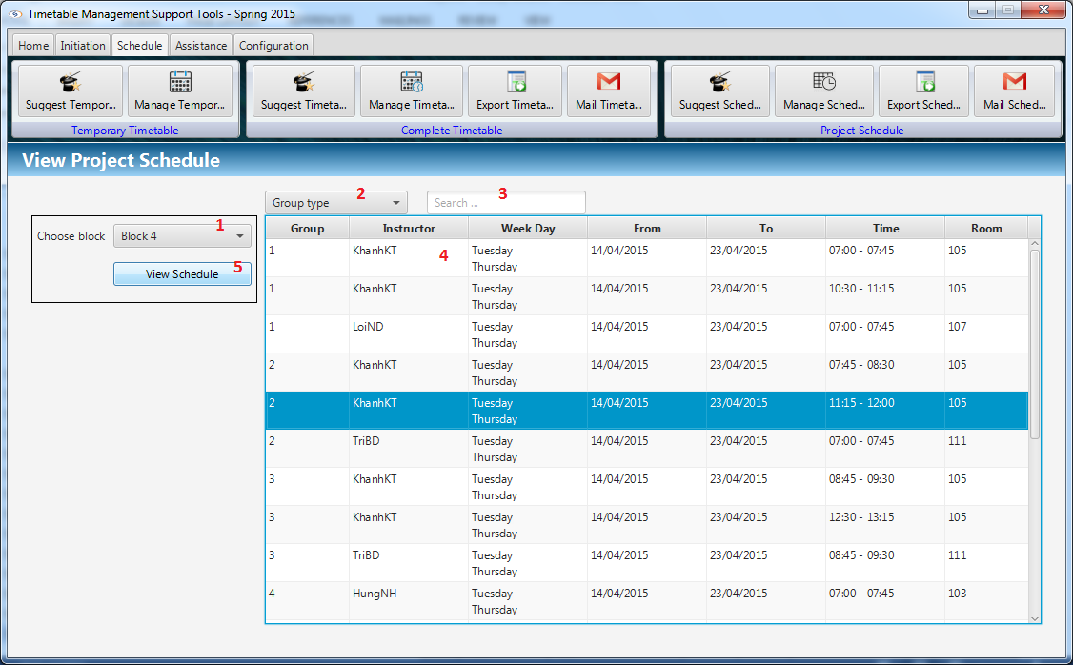

Figure : Manage Project Schedule

**Fields**

|  |  |  |  |  |  |  |  |
| --- | --- | --- | --- | --- | --- | --- | --- |
| **No** | **Field**  **Name** | **Description** | **Read**  **only** | **Mandatory** | **Control**  **Type** | **Data**  **Type** | **Length** |
| 1 | Block | Choice the block | No | Yes | Combo box | String | N/A |
| 2 | Group Type | Filter by group type | No | No | Combo box | String | N/A |
| 3 | Search | Filter by input text | No | No | Text Field | String | N/A |
| 4 | View data | Display schedule of each group. | Yes | No | Table View | String | N/A |

**Buttons**

|  |  |  |  |  |
| --- | --- | --- | --- | --- |
| No | Function | Description | Validation | Outcome |
| 5 | View Schedule | Show project schedule on table view. | N/A | Show project schedule on table view. |

#### Send mail (Project Schedule)

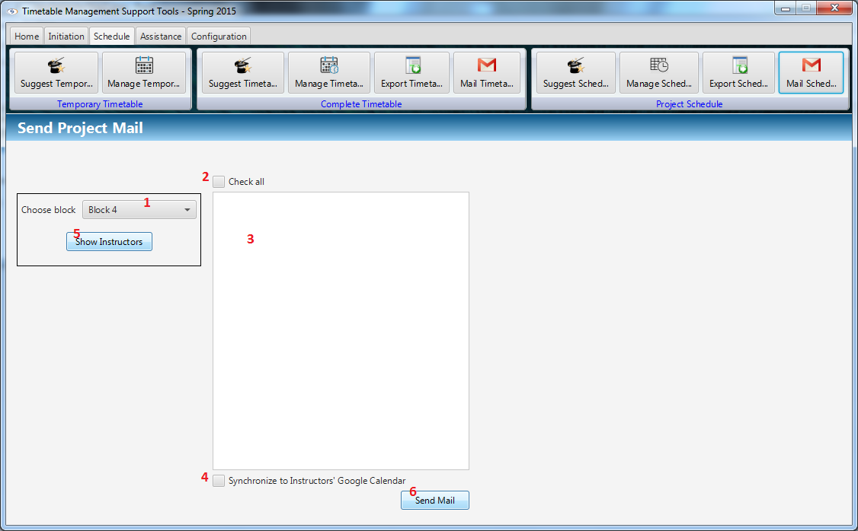

Figure : Send mail (Project Schedule)

**Fields**

|  |  |  |  |  |  |  |  |
| --- | --- | --- | --- | --- | --- | --- | --- |
| **No** | **Field**  **Name** | **Description** | **Read**  **only** | **Mandatory** | **Control**  **Type** | **Data**  **Type** | **Length** |
| 1 | Block | Choice the block | No | Yes | Combo box | String | N/A |
| 2 | Check all | Check all instructor in list view | No | No | Check box | Boolean | N/A |
| 3 | List Instructors | View instructors in a block | No | No | Checklist View | String | N/A |
| 4 | Synchronize | Synchronize schedule with Google Calendar | No | No | Check box | Boolean | N/A |

**Buttons**

|  |  |  |  |  |
| --- | --- | --- | --- | --- |
| No | Function | Description | Validation | Outcome |
| 5 | Show Instructors | Show instructors have class in block. | N/A | Show instructors have class in block and checked |
| 6 | Send Mail | Send timetable to instructor’s mail. | N/A | Send schedule to instructor’s mail. Synchronize with Google Calendar if Synchronize check box is selected. |

#### Export Project Schedule

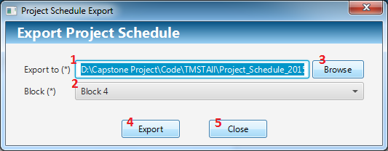

Figure : Export Project Schedule

**Fields**

|  |  |  |  |  |  |  |  |
| --- | --- | --- | --- | --- | --- | --- | --- |
| **No** | **Field**  **Name** | **Description** | **Read**  **only** | **Mandatory** | **Control**  **Type** | **Data**  **Type** | **Length** |
| 1 | File Path | View location of file to export | Yes | Yes | Text Field | String | N/A |
| 2 | Block | Choice the block | No | Yes | Combo box | String | N/A |

**Buttons**

|  |  |  |  |  |
| --- | --- | --- | --- | --- |
| No | Function | Description | Validation | Outcome |
| 3 | Browse | Open save dialog to choose location to save file. | N/A | Open save dialog to choose location to save file. View file path on text field File Path. |
| 4 | Export | Export data to excel file. | N/A | Export data to excel file on file path. |
| 5 | Close | Click to close window | N/A | Close this window. |

#### Calculate Timekeeping

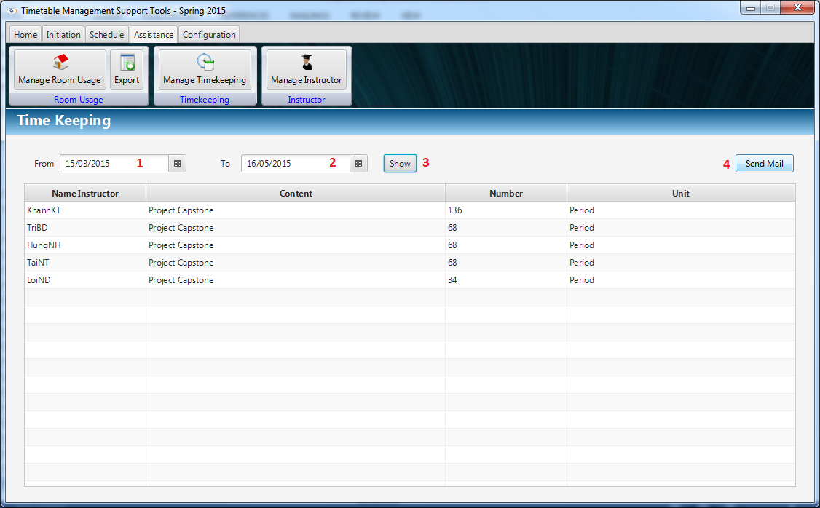

Figure : Calculate Timekeeping

**Fields**

|  |  |  |  |  |  |  |  |
| --- | --- | --- | --- | --- | --- | --- | --- |
| **No** | **Field**  **Name** | **Description** | **Read**  **only** | **Mandatory** | **Control**  **Type** | **Data**  **Type** | **Length** |
| 1 | From Date | Start time of timekeeping for calculating. | No | Yes | Date Picker | Date | N/A |
| 2 | To Date | End time of timekeeping for calculating. | No | Yes | Date Picker | Date | N/A |

**Buttons**

|  |  |  |  |  |
| --- | --- | --- | --- | --- |
| **No** | **Function** | **Description** | **Validation** | **Outcome** |
| 3 | Show | Calculate the timekeeping with values from date pickers. | N/A | Data will be shown in table |
| 4 | Send Mail | Send timekeeping mail to instructors | N/A | Navigate to Send Mail Dialog |

#### Send Timekeeping

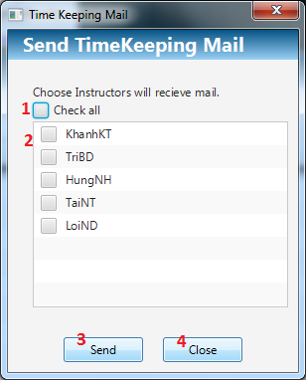

Figure : Send Timekeeping

**Fields**

|  |  |  |  |  |  |  |  |
| --- | --- | --- | --- | --- | --- | --- | --- |
| **No** | **Field**  **Name** | **Description** | **Read**  **only** | **Mandatory** | **Control**  **Type** | **Data**  **Type** | **Length** |
| 1 | Check all | Select all instructor | No | Yes | Checkbox | Boolean | N/A |
| 2 | Instructor | Select who will received timekeeping mail | No | Yes | Checklist View | Boolean | N/A |

**Buttons**

|  |  |  |  |  |
| --- | --- | --- | --- | --- |
| **No** | **Function** | **Description** | **Validation** | **Outcome** |
| 3 | Send | Send timekeeping mail to instructors | N/A | Windows will be closed |
| 4 | Close | Close the windows | N/A | Windows will be closed |

#### View Room Usage

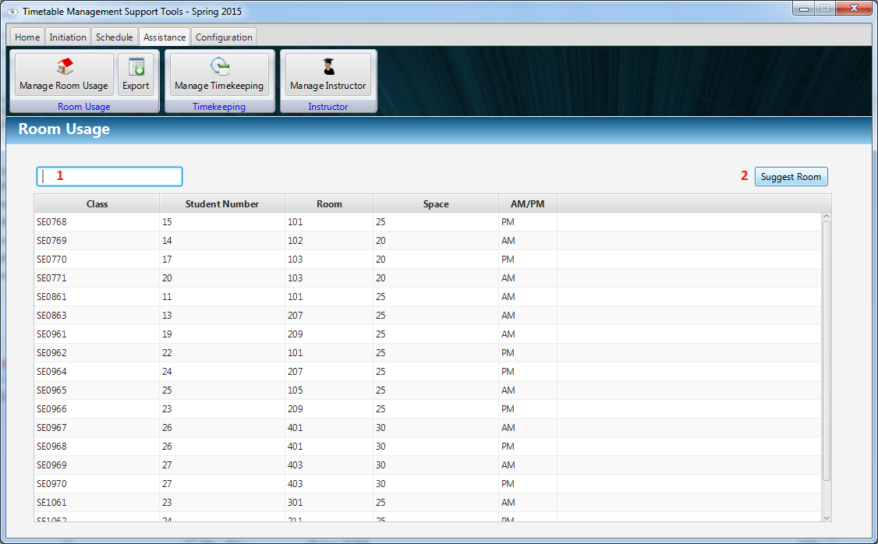

Figure : View Room Usage

**Fields**

|  |  |  |  |  |  |  |  |
| --- | --- | --- | --- | --- | --- | --- | --- |
| **No** | **Field**  **Name** | **Description** | **Read**  **only** | **Mandatory** | **Control**  **Type** | **Data**  **Type** | **Length** |
| 1 | Filter field | Filter data by rooms or classes | No | No | Textbox | String | N/A |

**Buttons**

|  |  |  |  |  |
| --- | --- | --- | --- | --- |
| **No** | **Function** | **Description** | **Validation** | **Outcome** |
| 2 | Suggest Room | Suggest rooms for user | N/A | Result of suggestion was shown |

#### Export Room Usage

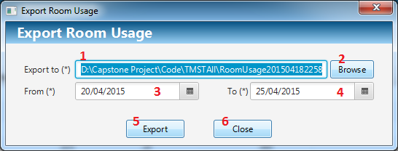

Figure : Export Room Usage

**Fields**

|  |  |  |  |  |  |  |  |
| --- | --- | --- | --- | --- | --- | --- | --- |
| **No** | **Field**  **Name** | **Description** | **Read**  **only** | **Mandatory** | **Control**  **Type** | **Data**  **Type** | **Length** |
| 1 | Export to | Location to export room usage excel file | Yes | Yes | Textbox | String | N/A |
| 3 | From Date | Start time of room usage for export. | No | Yes | Date Picker | Date | N/A |
| 4 | To Date | End time of room usage for export. | No | Yes | Date Picker | Date | N/A |

**Buttons**

|  |  |  |  |  |
| --- | --- | --- | --- | --- |
| **No** | **Function** | **Description** | **Validation** | **Outcome** |
| 2 | Browse | Suggest rooms for user | N/A | Open file chooser window |
| 5 | Export | Export excel file | N/A | Export file to specific location |
| 6 | Close | Close the windows | N/A | Windows will be closed |

## Database Design

### Logical Diagram

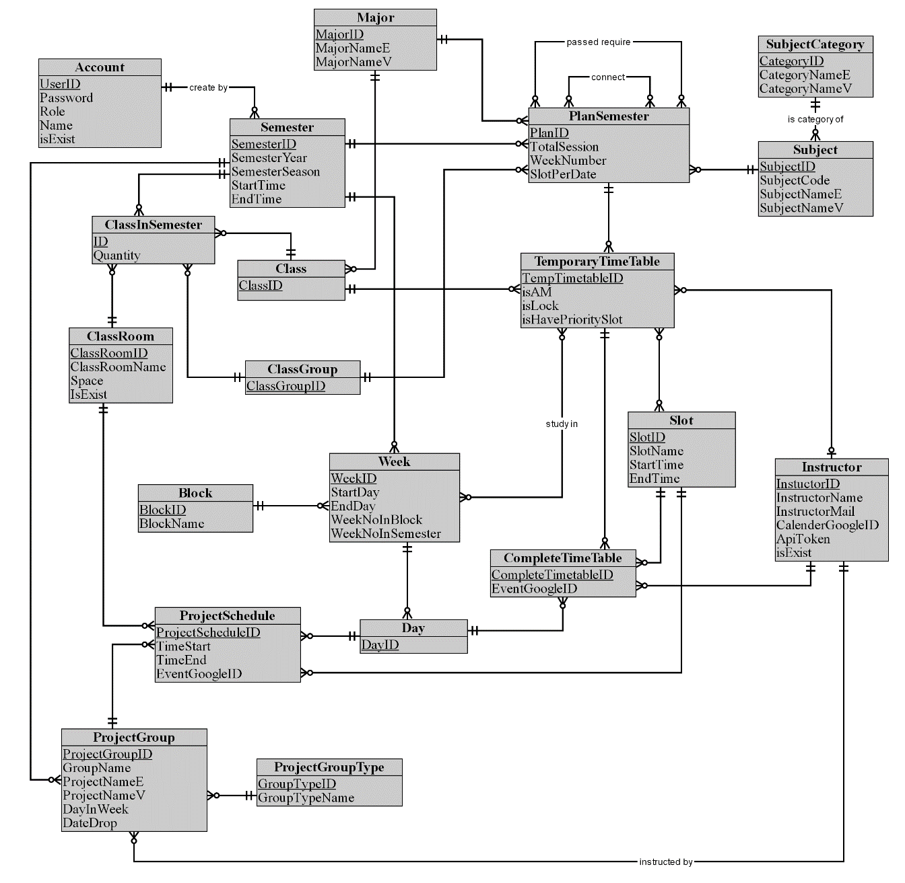

Figure : Logical Diagram

### Data Dictionary

|  |  |
| --- | --- |
| **Entity dictionary** | |
| **Entity Name** | **Description** |
| Account | Describe all user of the system. Each user has only one account. |
| Semester | Describe the semesters of FPT University, each semester at FPT University is about 4 months. |
| ClassRoom | Describe the rooms of FPT University which can be used for teaching. |
| Class | Describe the classes in FPT University. Each class is a set of students who have same courses. |
| ClassInSemester | Describe the specific class in a specific semester. |
| ClassGroup | Describe the sets of class in FPT University have the same plan in a semester. |
| Major | Describe the sets of class in FPT University have the same major. |
| Slot | Describe the slot in FPT University. Each slot is 90 minutes. |
| Day | Describe the official day in FPT University’s curriculum. Each day has 8 slots. |
| Week | Describe the week in FPT University’s curriculum. |
| Block | Describe the sets of weeks defined by FPT University. |
| Subject | Describe all available subject in FPT University. |
| SubjectCategory | Describe the sets of Subject. |
| PlanSemester | Describe the specific subjects which are available for each class group in a specific semester. Each semester has many plan semesters. |
| Instructor | Describe all instructors in FPT University. |
| CompletedTimetable | Describe the timetable in FPT University. Each timetable is about a set of answers for these question: which class has which subjects, teaching by who (instructor), at which specific period? |
| TemporaryTimetable | Describe the timetable in a brief description way. |
| ProjectGroup | Describe the set of students who is doing Capstone Project and Graduation Thesis. |
| ProjectGroupType | Describe the type of project group. |
| ProjectSchedule | Describe the time for meeting of project groups with their Instructor. |

Table : Entity Data Dictionary

|  |  |  |  |  |
| --- | --- | --- | --- | --- |
| **Entity name** | **Attributes** | **Description** | **Domain** | **Null** |
| Account | UserID {PK} | Account username | String, length: 50 | No |
| Password | Account password | String, length: 50 | No |
| Role | Unique identifier of a role (1: Admin, 2: Staff) | Integer | No |
| Name | Account username | Unicode String, length: 50 | No |
| isExist | Account status | Boolean | No |
| Semester | SemesterID {PK} | Unique identifier of a semester, auto increment | Integer | No |
| SemesterYear | Semester Year | Integer | No |
| SemesterSeason | Semester Season (Spring, Summer, Fall) | String, length: 30 | No |
| StartTime | The start date of semester | Date | No |
| EndTime | The end date of semester | Date | No |
| SubjectCategory | CategoryID {PK} | Unique identifier of a subject category | String, length: 10 | No |
| CategoryNameE | Subject category in English | String, length: 50 | No |
| CategoryNameV | Subject category in Vietnamese | Unicode String, length: 50 | No |
| Subject | SubjectCode {PK} | Unique identifier of a subject | String, length: 50 | No |
| SubjectNameE | Subject in Vietnamese | String, length: 100 | No |
| SubjectNameV | Subject in Vietnamese | Unicode String, length: 100 | No |
| PlanSemester | PlanID {PK} | Unique identifier of a plan, auto  increment | Integer | No |
| TotalSession | Total session of this plan | Integer | No |
| WeekNumber | Week number of plan in semester | Integer | No |
| SlotPerDate | Number of slot per date of plan | Integer | No |
| Major | MajorID {PK} | Unique identifier of a major, auto  increment | Unicode String, length: 10 | No |
| MajorNameE | Major in English | String, length: 100 | No |
| MajorNameV | Major in Vietnamese | Unicode String, length: 100 | No |
| ClassGroup | ClassGroupID {PK} | Unique identifier of a class group | String, length: 20 | No |
| Class | ClassID {PK} | Name of class, unique identifier | String, length: 10 | No |
| ClassInSemester | ID {PK} | Unique identifier, auto  increment | Integer | No |
| Quantity | Number of student of class in this semester | Integer | No |
| ClassRoom | ClassRoomID {PK} | Unique identifier of a classroom, auto  increment | Integer | No |
| ClassRoomName | Name of classroom | Unicode String, length: 30 | No |
| Space | Room space | Integer | No |
| IsExist | Classroom status | Boolean | No |
| TemporaryTimeTable | TempTimetableID {PK} | Unique identifier of a course, auto  Increment | Integer | No |
| isAM | Identity the course study in AM or PM | Boolean | No |
| isLock | Identity if the course is locked. If the course is lock, no action affect it. | Boolean | No |
| isHavePrioritySlot | Identity if the course have priority slot. | Boolean | No |
| Slot | SlotID {PK} | Unique identifier of a slot | Integer | No |
| SlotName | Slot name | String, length: 10 | No |
| StartTime | Start time of the slot | Time, length: 7 | No |
| EndTime | End time of the slot | Time, length: 7 | No |
| Instructor | InstuctorID {PK} | Unique identifier of an instructor | String, length: 30 | No |
| InstructorName | Name of instructor | Unicode String, length: 50 | No |
| InstructorMail | Mail of instructor | String, length: 100 | No |
| CalenderGoogleID | Calendar ID in Google calendar | String, length: 100 | Yes |
| ApiToken | Access token to synchronize Google calendar | String, length: 100 | Yes |
| isExist | Instructor status | Boolean | No |
| Block | BlockID {PK} | Unique identifier of a block | Integer | No |
| BlockName | Block name | String, length: 10 | No |
| Week | WeekID {PK} | Unique identifier of a week, auto  increment | Integer | No |
| StartDay | The start date of this week | Date | No |
| EndDay | The end date of this week | Date | No |
| WeekNoInBlock | Ordinal numbers of week in a block | Integer | No |
| WeekNoInSemester | Ordinal numbers of week in the semester | Integer | No |
| Day | DayID {PK} | Unique identifier of a date | Date | No |
| CompleteTimeTable | CompleteTimetableID {PK} | Unique identifier of a complete timetable, auto  increment | Integer | No |
| EventGoogleID | The Google event ID in Google calendar | String, length: 100 | Yes |
| ProjectGroupType | GroupTypeID {PK} | Unique identifier of a project group type | String, length: 5 | No |
| GroupTypeName | Group type name | String, length: 30 | No |
| ProjectGroup | ProjectGroupID {PK} | Unique identifier of a group, auto  increment | Integer | No |
| GroupName | Name of group | Unicode String, length: 30 | No |
| ProjectNameE | Project topic in English | String, length: 200 | No |
| ProjectNameV | Project topic in Vietnamese | Unicode String, length: 200 | No |
| DayInWeek | Number of date per week which instructor has meeting with students | Integer | No |
| DateDrop | The drop date of the group | Date | Yes |
| ProjectSchedule | ProjectScheduleID {PK} | Unique identifier of a projects schedule, auto  increment | Integer | No |
| TimeStart | The start time of meeting | Time, length: 7 | No |
| TimeEnd | The end time of meeting | Time, length: 7 | No |
| EventGoogleID | The Google event ID in Google calendar | String, length: 100 | Yes |

Table : Detail Data Dictionary

## Algorithms

### Suggest Temporary Timetable

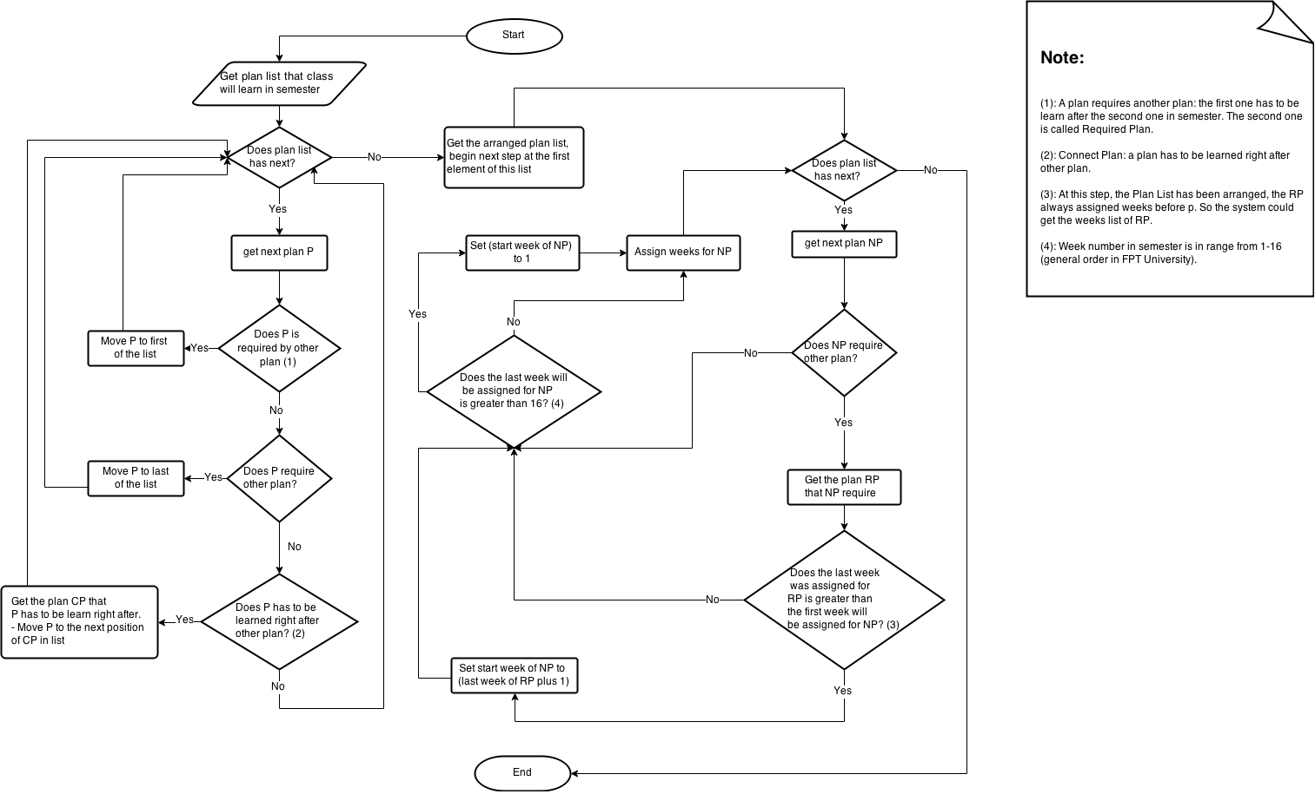

Figure : Suggest Temporary Timetable

### Suggest Complete Timetable

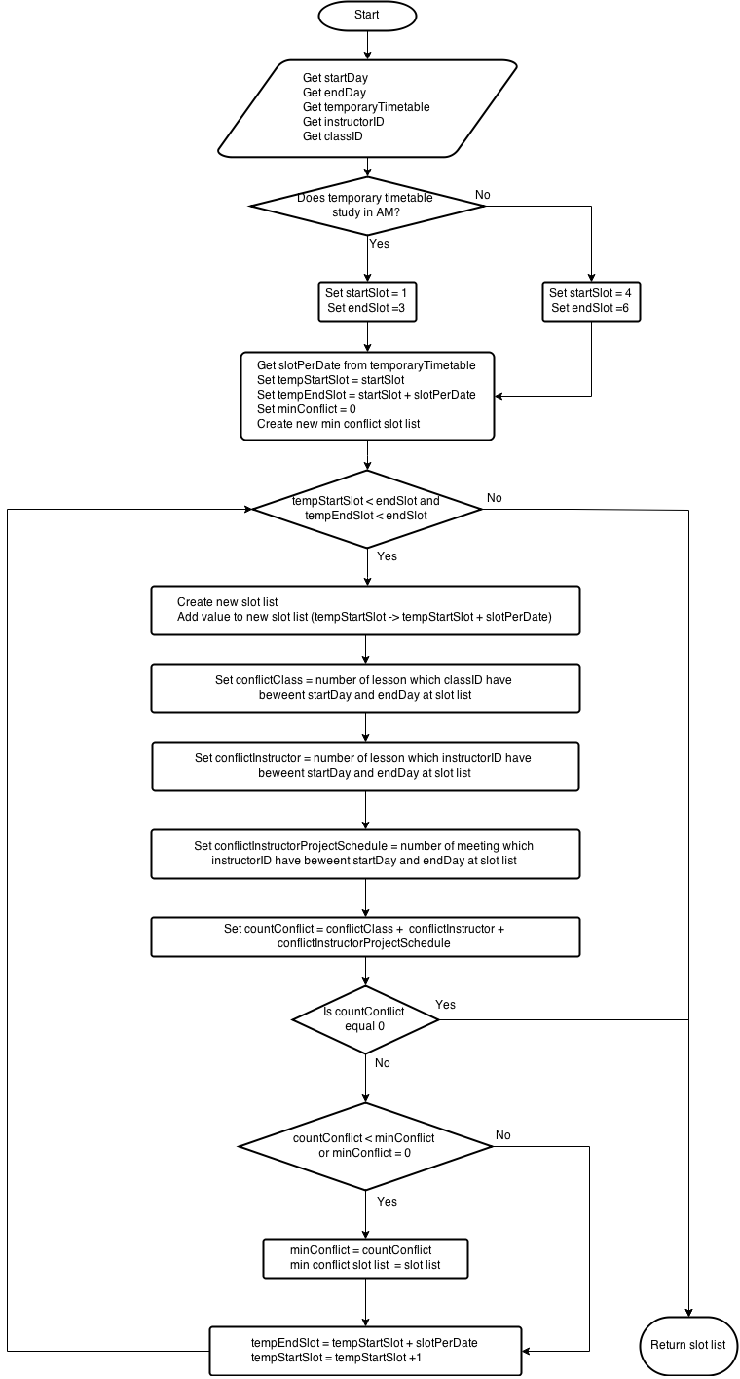

Figure : Suggest Complete Timetable

### Choose Slot

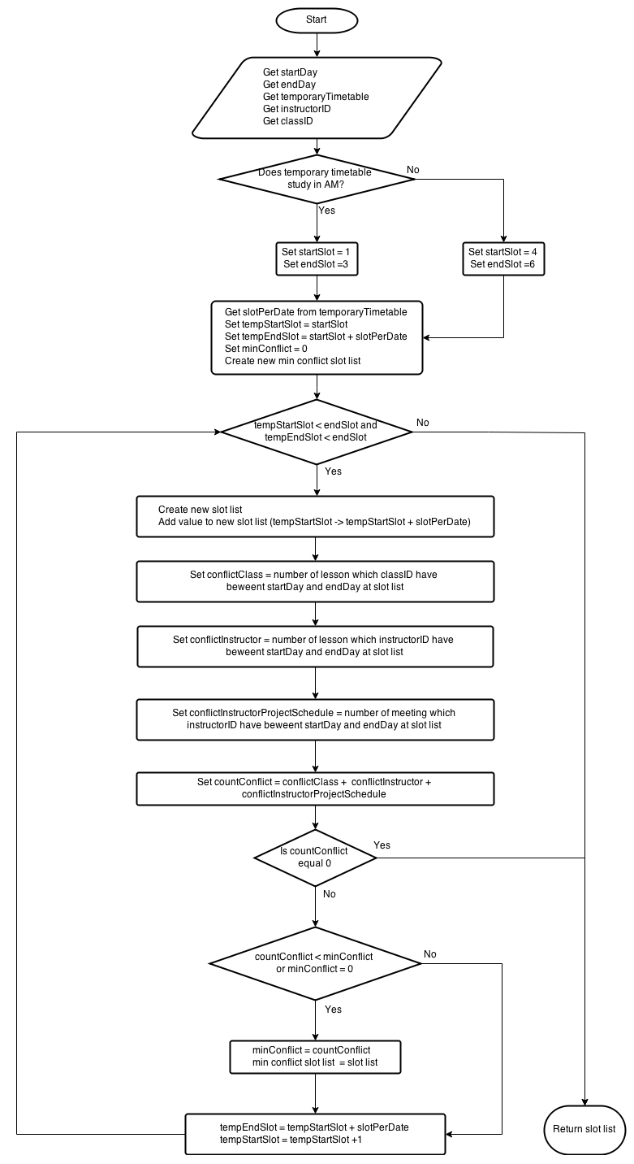

Figure : Choose Slot

### Suggest Room

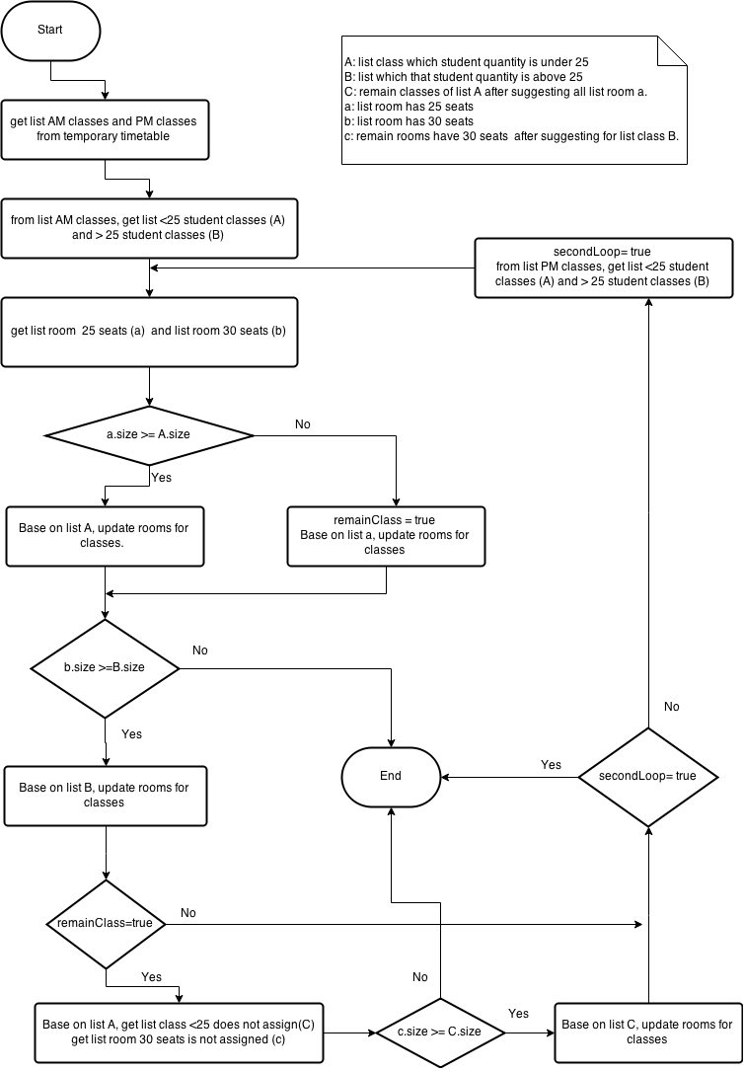

Figure : Suggest Room

### Suggest Guide Project Schedule

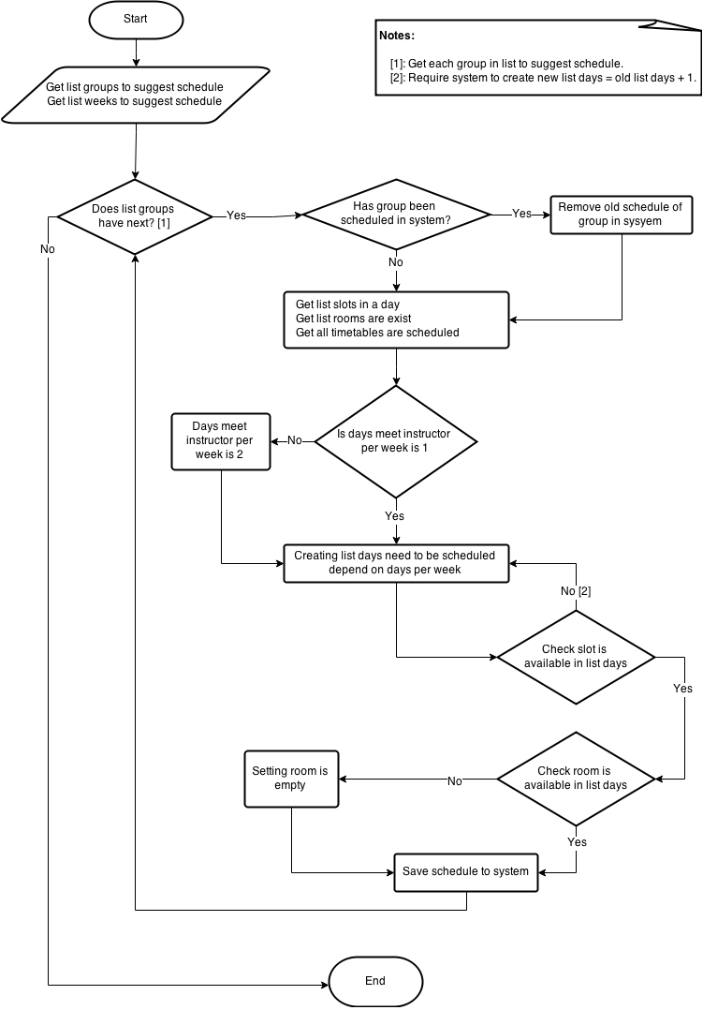

Figure : Suggest Guide Project Schedule